|  |  |
| --- | --- |
| Woman Safty App | Students   1. Amal Ahmed Hakami 🡪 202000886 2. Sharifah ali albakkari 🡪 202102444 3. Ashjan Faisal altherwi 🡪 202103854 4. Rawan othman 🡪 202185952   Class   * 2152   Course   * Mobile Applications Development 343 |
|  |  |

**Table**

**Introduction:** 2

**Registration Process:** 2

**Alert Interface:** 3

**Database Linking:** 3

**Conclusion:** 3

**Screen Shots:** 4

• activity_basic_login 4

• activity_fake_call 5

• activity_guardian_information 5

• activity_guardian_login 6

• activity_main 6

• activity_otp 7

• activity_register 7

• activity_splashh_screen 8

• activity_user_login 8

• activity_contact 9

**XML Codes:** 9

• activity_basic_login 9

• activity_fake_call 11

• activity_guardian_information 11

• activity_guardian_login 13

• activity_main 15

• activity_otp 17

• activity_register 18

• activity_splashh_screen 21

• activity_user_login 22

• activity_contact 24

**Java Codes:** 28

• BasicLoginActivity 28

• FakeCallActivity 30

• GuardianInfo 31

• GuardianInformationActivity 32

• GuardianLoginActivity 33

• LocationInfo 37

• MainActivity 38

• MapsActivity 46

• MapsActivity2 48

• MyLocation 52

• MyLocationSecond 52

• MySMSBroadcastReceiver 53

• MyLocation 54

• OTPActivity 54

• RegisterActivity 58

• SplashhScreenActivity 60

• UserData 61

• UserLoginActivity 62

# **Introduction:**

The Women's Safety Android Application is designed to help women protect themselves in case of danger. The application alerts one of the user's designated relatives with a message and her current location via a map. The purpose of this report is to provide a detailed overview of the features and functionality of the Women's Safety Android Application.

# **Registration Process:**

The user starts by registering an account by providing their personal information including name, age, gender, and phone number along with the country key. The information is collected to create an account for the user on the application. This information is necessary to ensure that the user can be easily identified in case of an emergency.

The application then sends a one-time password (OTP) verification code to the entered phone number through Firebase. The OTP is sent to verify that the phone number entered by the user is correct and belongs to the user. This helps to prevent unauthorized access to the user's account and ensures that the information entered is accurate.

# **Alert Interface:**

After verifying the phone number, the user can enter the name and phone number of a relative. This relative is the person who will receive the alert message in case of an emergency. The relative's information is stored in the database and can be easily accessed in case of an emergency.

The alert interface is activated by shaking the phone in a certain way. The application is designed to detect the shaking of the phone and immediately send a message requesting assistance to the relative's phone. The message sent includes the user's current location, which is determined using GPS technology. This location information can be viewed on a map within the application.

In addition to sending the alert message, the user can also simulate contact with the relative from within the application. This feature allows the user to practice using the application and get familiar with its features.

# **Database Linking:**

The relative verifies the request on their mobile phone and enters the phone number of the woman in question along with the country key. This links the relative and the woman in the Firebase database. This linking system ensures that the relative receives the alert message in case of an emergency and provides a direct connection between the two. This helps to ensure that the necessary assistance is provided to the user in a timely manner.

# **Conclusion:**

In conclusion, the Women's Safety Android Application provides a comprehensive solution for women to protect themselves in case of danger. The easy registration process, the alert interface, and the database linking system work seamlessly to provide the necessary assistance to the user in an emergency. The application is designed to be user-friendly and accessible to all, making it an effective tool for women's safety. Although the application is not yet completed and has some bugs that need to be resolved in the future, it has the potential to greatly enhance the safety of women and provide peace of mind in dangerous situations.

# **Screen Shots:**

* activity_basic_login

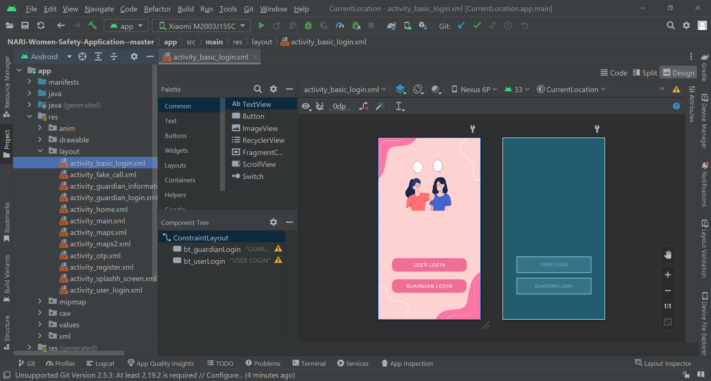

* activity_fake_call

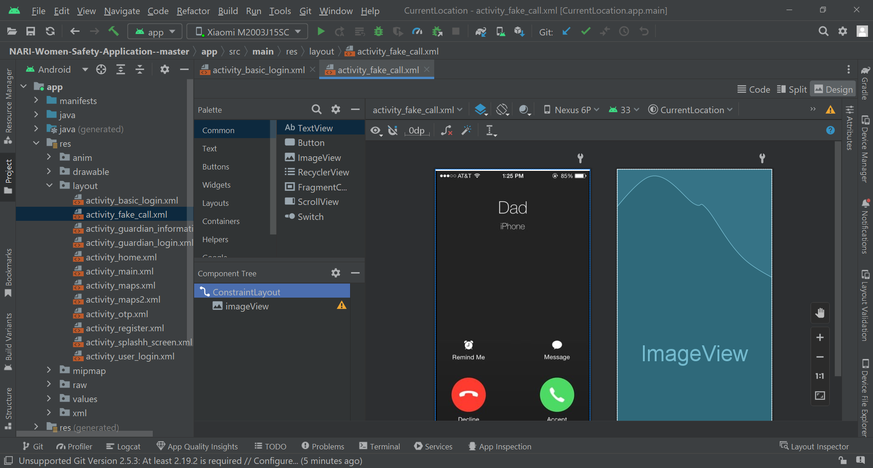

* activity_guardian_information

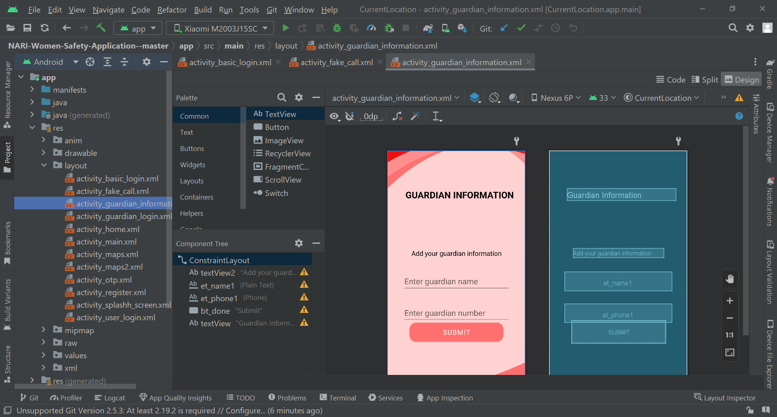

* activity_guardian_login

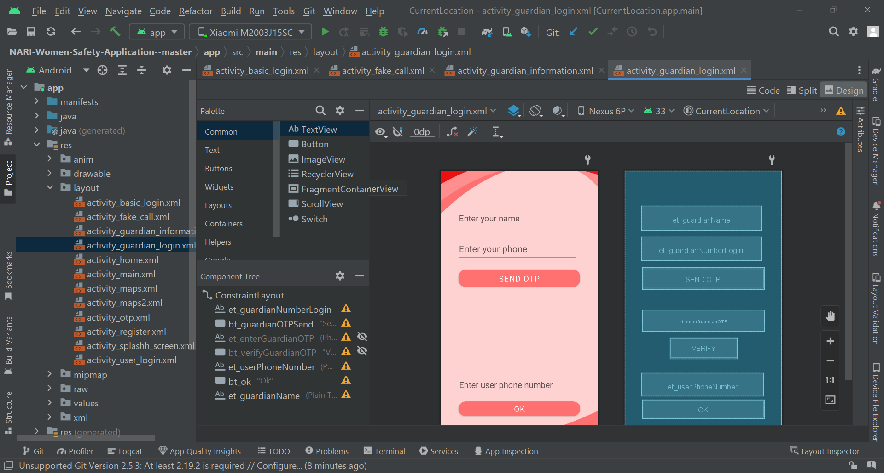

* activity_main

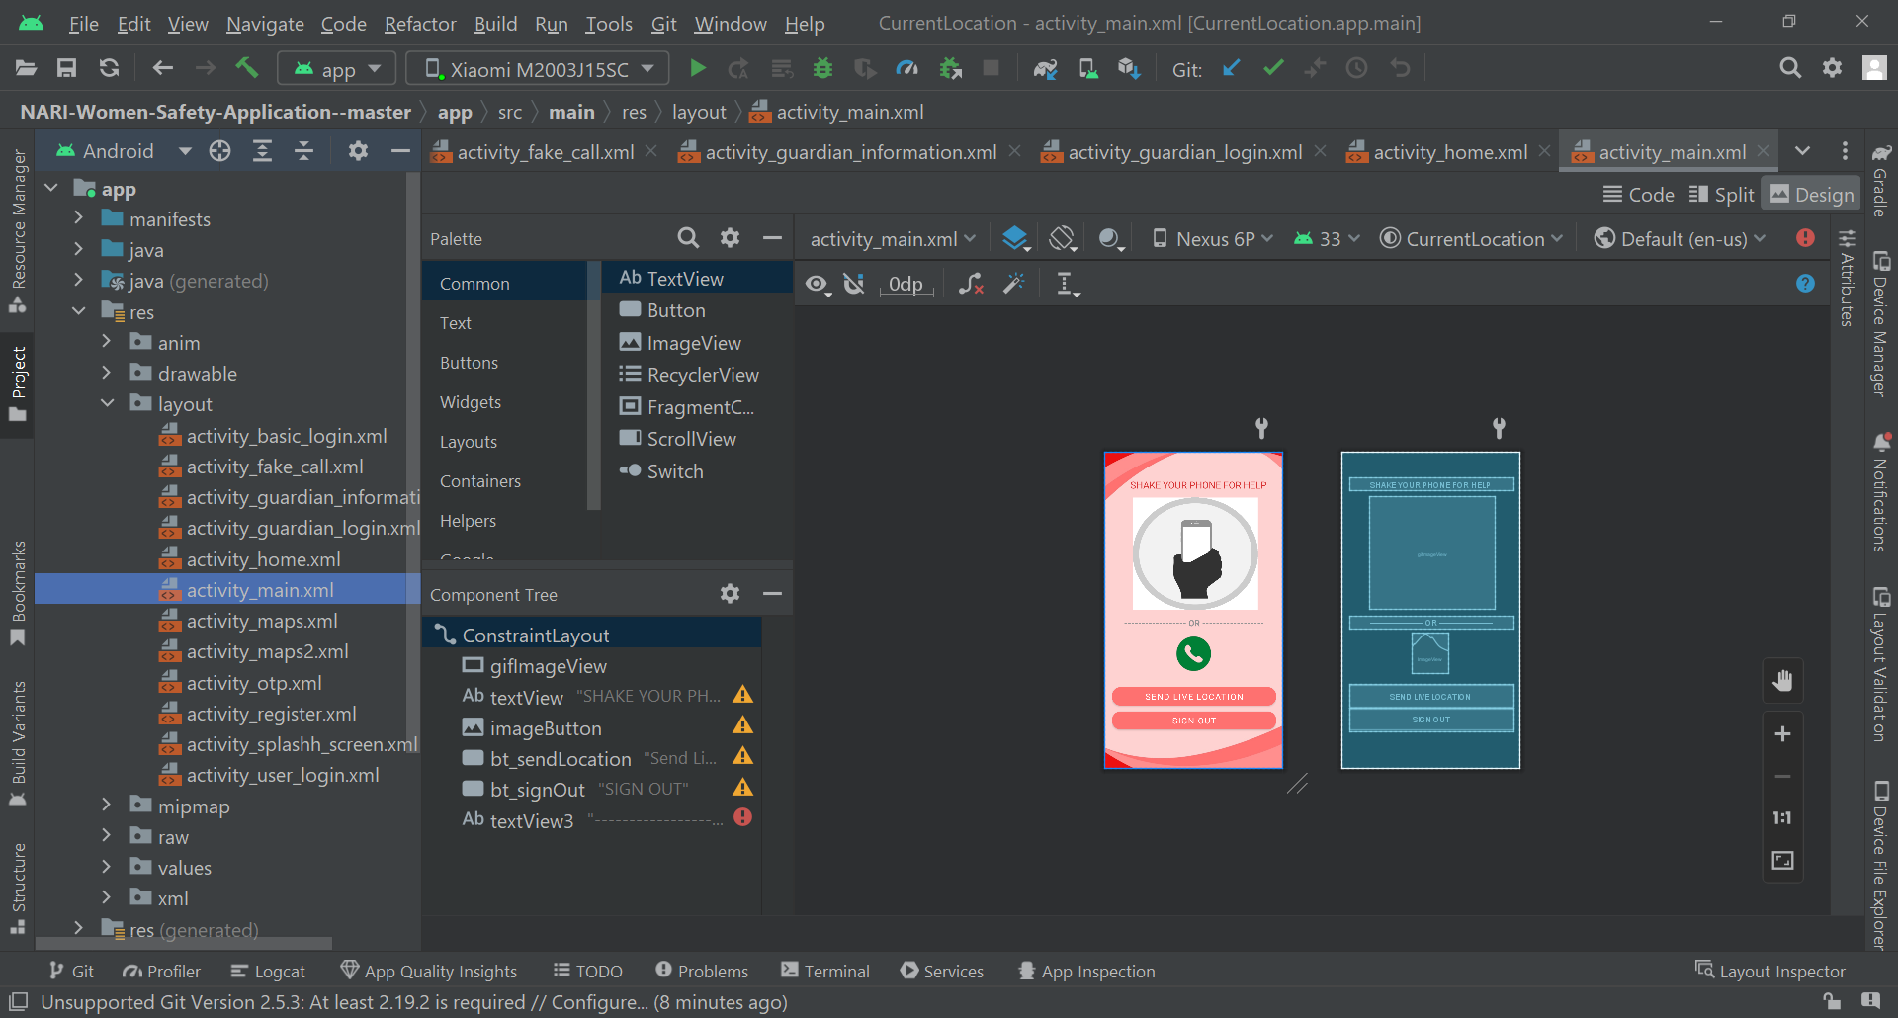

* activity_otp

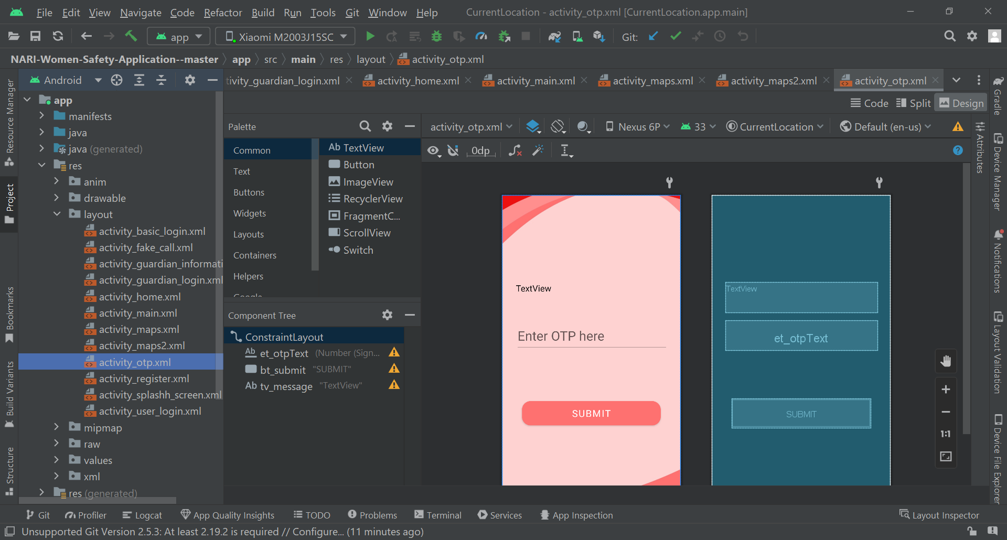

* activity_register

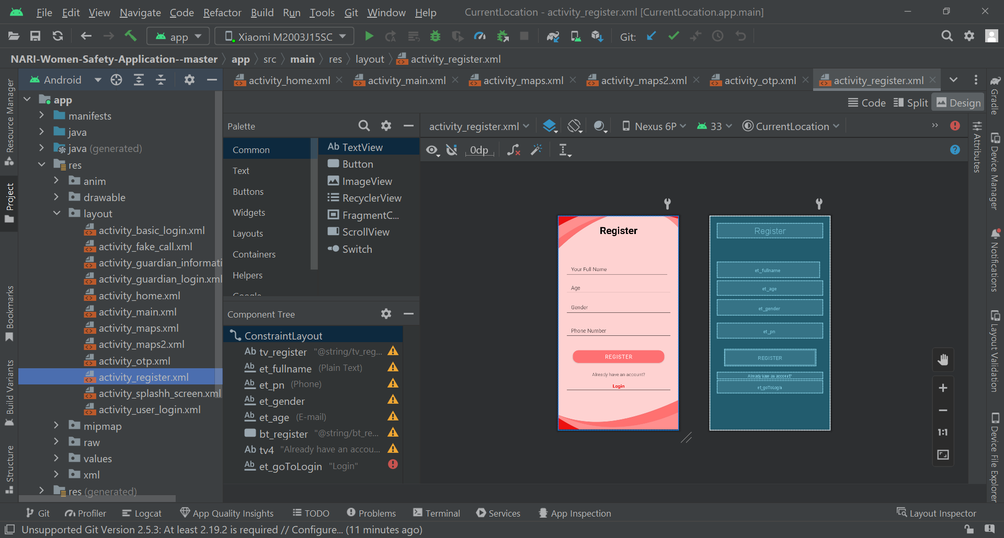

* activity_splashh_screen

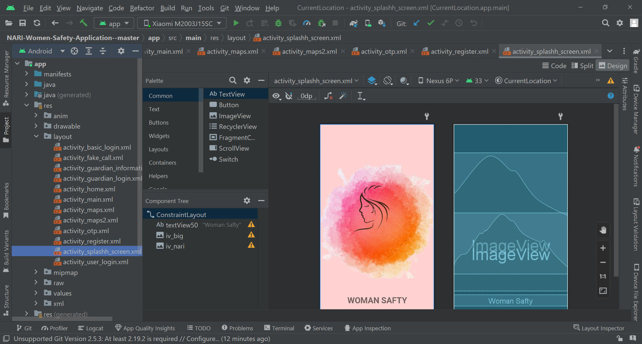

* activity_user_login

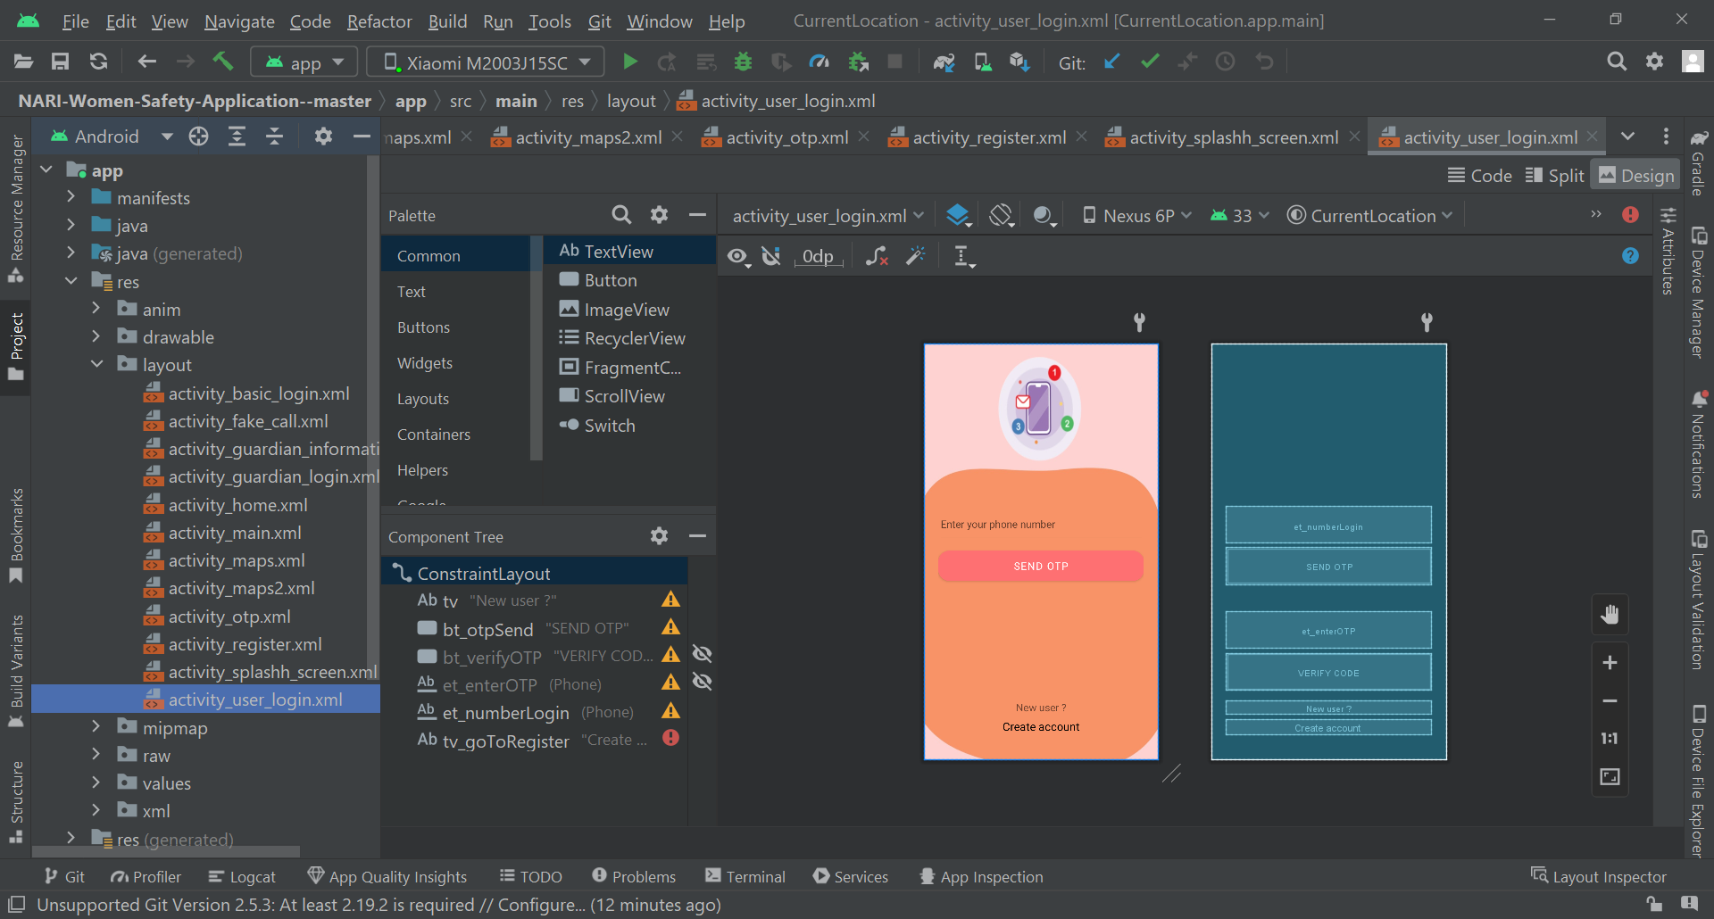

* activity_contact

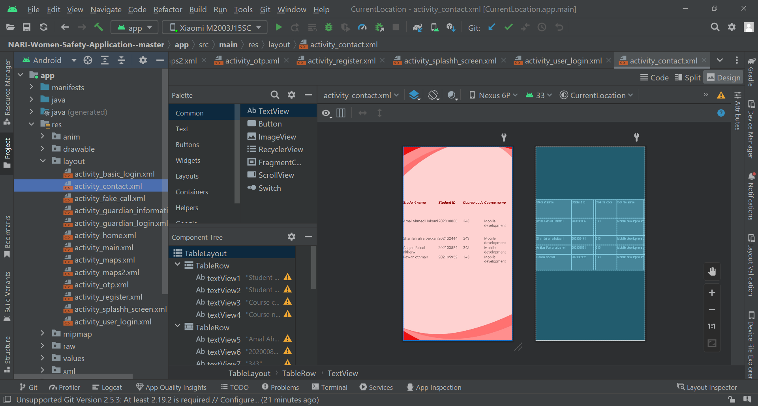

# **XML Codes:**

* activity_basic_login

<?xml version="1.0" encoding="utf-8"?>  
<androidx.constraintlayout.widget.ConstraintLayout xmlns:android="http://schemas.android.com/apk/res/android"  
 xmlns:app="http://schemas.android.com/apk/res-auto"  
 xmlns:tools="http://schemas.android.com/tools"  
 android:layout_width="match_parent"  
 android:layout_height="match_parent"  
 android:background="@drawable/basic_login_bg"  
 tools:context=".MainActivity">  
  
 <Button  
 android:id="@+id/bt_contact"  
 android:layout_width="299dp"  
 android:layout_height="65dp"  
 android:backgroundTint="#80ED6E93"  
 android:backgroundTintMode="src_in"  
 android:fontFamily="sans-serif"  
 android:text="Contact"  
 android:textColorLink="#fff"  
 android:textSize="20sp"  
 app:cornerRadius="20dp"  
 app:layout_constraintBottom_toBottomOf="parent"  
 app:layout_constraintEnd_toEndOf="parent"  
 app:layout_constraintStart_toStartOf="parent"  
 app:layout_constraintTop_toTopOf="parent"  
 app:layout_constraintVertical_bias="0.975"  
 app:strokeColor="#000" />  
  
 <Button  
 android:id="@+id/bt_guardianLogin"  
 android:layout_width="299dp"  
 android:layout_height="65dp"  
 android:backgroundTint="#EE6E94"  
 android:fontFamily="sans-serif"  
 android:text="GUARDIAN LOGIN"  
 android:textSize="20sp"  
 app:cornerRadius="20dp"  
 app:layout_constraintBottom_toBottomOf="parent"  
 app:layout_constraintEnd_toEndOf="parent"  
 app:layout_constraintStart_toStartOf="parent"  
 app:layout_constraintTop_toTopOf="parent"  
 app:layout_constraintVertical_bias="0.845" />  
  
 <Button  
 android:id="@+id/bt_userLogin"  
 android:layout_width="300dp"  
 android:layout_height="65dp"  
 android:layout_marginBottom="20dp"  
 android:backgroundTint="#EF6E95"  
 android:fontFamily="sans-serif"  
 android:text="USER LOGIN"  
 android:textSize="20sp"  
 app:cornerRadius="20dp"  
 app:layout_constraintBottom_toTopOf="@+id/bt_guardianLogin"  
 app:layout_constraintEnd_toEndOf="parent"  
 app:layout_constraintHorizontal_bias="0.504"  
 app:layout_constraintStart_toStartOf="parent" />  
  
</androidx.constraintlayout.widget.ConstraintLayout>

* activity_fake_call

<?xml version="1.0" encoding="utf-8"?>  
<androidx.constraintlayout.widget.ConstraintLayout xmlns:android="http://schemas.android.com/apk/res/android"  
 xmlns:app="http://schemas.android.com/apk/res-auto"  
 xmlns:tools="http://schemas.android.com/tools"  
 android:layout_width="match_parent"  
 android:layout_height="match_parent"  
 tools:context=".FakeCallActivity">  
  
 <ImageView  
 android:id="@+id/imageView"  
 android:layout_width="match_parent"  
 android:layout_height="match_parent"  
 app:layout_constraintEnd_toEndOf="parent"  
 app:layout_constraintStart_toStartOf="parent"  
 app:srcCompat="@drawable/fake_call"  
 tools:layout_editor_absoluteY="210dp" />  
</androidx.constraintlayout.widget.ConstraintLayout>

* activity_guardian_information

<?xml version="1.0" encoding="utf-8"?>  
<androidx.constraintlayout.widget.ConstraintLayout xmlns:android="http://schemas.android.com/apk/res/android"  
 xmlns:app="http://schemas.android.com/apk/res-auto"  
 xmlns:tools="http://schemas.android.com/tools"  
 android:layout_width="match_parent"  
 android:layout_height="match_parent"  
 android:background="@drawable/activity_guardian_login_bg"  
 tools:context=".GuardianInformationActivity">  
  
 <TextView  
 android:id="@+id/textView2"  
 android:layout_width="wrap_content"  
 android:layout_height="wrap_content"  
 android:layout_marginTop="292dp"  
 android:fontFamily="sans-serif"  
 android:text="Add your guardian information"  
 android:textColor="@color/black"  
 android:textSize="20sp"  
 android:textStyle="normal"  
 app:layout_constraintEnd_toEndOf="parent"  
 app:layout_constraintStart_toStartOf="parent"  
 app:layout_constraintTop_toTopOf="parent" />  
  
 <EditText  
 android:id="@+id/et_name1"  
 android:layout_width="320dp"  
 android:layout_height="58dp"  
 android:layout_marginTop="360dp"  
 android:ems="10"  
 android:fontFamily="sans-serif"  
 android:hint="Enter guardian name"  
 android:inputType="textPersonName"  
 android:textColor="#090909"  
 android:textSize="24sp"  
 app:layout_constraintEnd_toEndOf="parent"  
 app:layout_constraintStart_toStartOf="parent"  
 app:layout_constraintTop_toTopOf="parent" />  
  
 <EditText  
 android:id="@+id/et_phone1"  
 android:layout_width="320dp"  
 android:layout_height="55dp"  
 android:layout_marginTop="456dp"  
 android:ems="10"  
 android:fontFamily="sans-serif"  
 android:hint="Enter guardian number"  
 android:inputType="phone"  
 android:textColor="#020202"  
 android:textSize="24sp"  
 app:layout_constraintEnd_toEndOf="parent"  
 app:layout_constraintStart_toStartOf="parent"  
 app:layout_constraintTop_toTopOf="parent" />  
  
 <Button  
 android:id="@+id/bt_done"  
 android:layout_width="280dp"  
 android:layout_height="69dp"  
 android:layout_marginBottom="156dp"  
 android:backgroundTint="#FE7170"  
 android:fontFamily="sans-serif"  
 android:text="Submit"  
 android:textSize="20sp"  
 app:cornerRadius="20dp"  
 app:layout_constraintBottom_toBottomOf="parent"  
 app:layout_constraintEnd_toEndOf="parent"  
 app:layout_constraintStart_toStartOf="parent"  
 app:rippleColor="#ffff" />  
  
 <TextView  
 android:id="@+id/textView"  
 android:layout_width="wrap_content"  
 android:layout_height="wrap_content"  
 android:layout_marginTop="112dp"  
 android:fontFamily="sans-serif"  
 android:text="Guardian Information"  
 android:textAllCaps="true"  
 android:textColor="@color/black"  
 android:textSize="27sp"  
 android:textStyle="bold"  
 app:layout_constraintEnd_toEndOf="parent"  
 app:layout_constraintHorizontal_bias="0.611"  
 app:layout_constraintStart_toStartOf="parent"  
 app:layout_constraintTop_toTopOf="parent" />  
</androidx.constraintlayout.widget.ConstraintLayout>

* activity_guardian_login

<?xml version="1.0" encoding="utf-8"?>  
<androidx.constraintlayout.widget.ConstraintLayout xmlns:android="http://schemas.android.com/apk/res/android"  
 xmlns:app="http://schemas.android.com/apk/res-auto"  
 xmlns:tools="http://schemas.android.com/tools"  
 android:layout_width="match_parent"  
 android:layout_height="match_parent"  
 android:background="@drawable/activity_guardian_login_bg"  
 tools:context=".GuardianLoginActivity">  
  
 <EditText  
 android:id="@+id/et_guardianNumberLogin"  
 android:layout_width="314dp"  
 android:layout_height="63dp"  
 android:layout_marginTop="17dp"  
 android:ems="10"  
 android:fontFamily="sans-serif"  
 android:hint="Enter your phone"  
 android:inputType="phone"  
 android:textColor="#070707"  
 android:textSize="24sp"  
 app:layout_constraintEnd_toEndOf="parent"  
 app:layout_constraintHorizontal_bias="0.443"  
 app:layout_constraintStart_toStartOf="parent"  
 app:layout_constraintTop_toBottomOf="@+id/et_guardianName" />  
  
 <Button  
 android:id="@+id/bt_guardianOTPSend"  
 android:layout_width="320dp"  
 android:layout_height="58dp"  
 android:layout_marginTop="17dp"  
 android:backgroundTint="#FE7170"  
 android:fontFamily="sans-serif"  
 android:text="Send OTP"  
 android:textSize="20sp"  
 android:typeface="sans"  
 app:cornerRadius="20dp"  
 app:layout_constraintEnd_toEndOf="parent"  
 app:layout_constraintStart_toStartOf="parent"  
 app:layout_constraintTop_toBottomOf="@+id/et_guardianNumberLogin" />  
  
 <EditText  
 android:id="@+id/et_enterGuardianOTP"  
 android:layout_width="320dp"  
 android:layout_height="56dp"  
 android:layout_marginTop="54dp"  
 android:background="@drawable/activity_guardian_login_bg"  
 android:ems="10"  
 android:fontFamily="sans-serif"  
 android:inputType="phone"  
 android:visibility="invisible"  
 app:layout_constraintEnd_toEndOf="parent"  
 app:layout_constraintStart_toStartOf="parent"  
 app:layout_constraintTop_toBottomOf="@+id/bt_guardianOTPSend" />  
  
 <Button  
 android:id="@+id/bt_verifyGuardianOTP"  
 android:layout_width="177dp"  
 android:layout_height="55dp"  
 android:layout_marginTop="16dp"  
 android:text="Verify"  
 android:textSize="20sp"  
 android:visibility="invisible"  
 app:layout_constraintEnd_toEndOf="parent"  
 app:layout_constraintStart_toStartOf="parent"  
 app:layout_constraintTop_toBottomOf="@+id/et_enterGuardianOTP" />  
  
 <EditText  
 android:id="@+id/et_userPhoneNumber"  
 android:layout_width="320dp"  
 android:layout_height="60dp"  
 android:layout_marginTop="532dp"  
 android:ems="10"  
 android:hint="Enter user phone number"  
 android:inputType="phone"  
 android:textColor="#050505"  
 android:textSize="22sp"  
 app:layout_constraintEnd_toEndOf="parent"  
 app:layout_constraintHorizontal_bias="0.476"  
 app:layout_constraintStart_toStartOf="parent"  
 app:layout_constraintTop_toTopOf="parent"  
 tools:ignore="SpeakableTextPresentCheck" />  
  
 <Button  
 android:id="@+id/bt_ok"  
 android:layout_width="320dp"  
 android:layout_height="50dp"  
 android:layout_marginTop="8dp"  
 android:backgroundTint="#FE7170"  
 android:fontFamily="sans-serif"  
 android:text="Ok"  
 android:textSize="20sp"  
 android:typeface="sans"  
 app:cornerRadius="20dp"  
 app:layout_constraintBottom_toBottomOf="parent"  
 app:layout_constraintEnd_toEndOf="parent"  
 app:layout_constraintStart_toStartOf="parent"  
 app:layout_constraintTop_toBottomOf="@+id/et_userPhoneNumber"  
 app:layout_constraintVertical_bias="0.0" />  
  
 <EditText  
 android:id="@+id/et_guardianName"  
 android:layout_width="314dp"  
 android:layout_height="63dp"  
 android:layout_marginTop="92dp"  
 android:ems="10"  
 android:fontFamily="sans-serif"  
 android:hint="Enter your name"  
 android:inputType="textPersonName"  
 android:textSize="22sp"  
 app:layout_constraintEnd_toEndOf="parent"  
 app:layout_constraintHorizontal_bias="0.443"  
 app:layout_constraintStart_toStartOf="parent"  
 app:layout_constraintTop_toTopOf="parent" />  
  
</androidx.constraintlayout.widget.ConstraintLayout>

* activity_main

<?xml version="1.0" encoding="utf-8"?>  
<androidx.constraintlayout.widget.ConstraintLayout xmlns:android="http://schemas.android.com/apk/res/android"  
 xmlns:app="http://schemas.android.com/apk/res-auto"  
 xmlns:tools="http://schemas.android.com/tools"  
 android:layout_width="match_parent"  
 android:layout_height="match_parent"  
 android:background="@drawable/activity_guardian_login_bg"  
 android:padding="16dp">  
  
  
 <pl.droidsonroids.gif.GifImageView  
 android:id="@+id/gifImageView"  
 android:layout_width="290dp"  
 android:layout_height="260dp"  
 android:layout_marginTop="88dp"  
 android:background="#fff"  
 android:scaleType="fitXY"  
 android:src="@drawable/gif"  
 app:layout_constraintEnd_toEndOf="parent"  
 app:layout_constraintHorizontal_bias="0.529"  
 app:layout_constraintStart_toStartOf="parent"  
 app:layout_constraintTop_toTopOf="parent" />  
  
 <TextView  
 android:id="@+id/textView"  
 android:layout_width="match_parent"  
 android:layout_height="wrap_content"  
 android:layout_marginTop="44dp"  
 android:fontFamily="sans-serif"  
 android:paddingLeft="20dp"  
 android:text="SHAKE YOUR PHONE FOR HELP"  
 android:textAlignment="center"  
 android:textColor="#D83535"  
 android:textSize="22sp"  
 app:layout_constraintEnd_toEndOf="parent"  
 app:layout_constraintHorizontal_bias="0.831"  
 app:layout_constraintStart_toStartOf="parent"  
 app:layout_constraintTop_toTopOf="parent" />  
  
 <ImageView  
 android:id="@+id/imageButton"  
 android:layout_width="83dp"  
 android:layout_height="94dp"  
 android:layout_marginTop="400dp"  
 android:clickable="true"  
 android:scaleType="centerCrop"  
 app:layout_constraintEnd_toEndOf="parent"  
 app:layout_constraintStart_toStartOf="parent"  
 app:layout_constraintTop_toTopOf="parent"  
 app:srcCompat="@drawable/fc"  
 tools:ignore="SpeakableTextPresentCheck" />  
  
 <Button  
 android:id="@+id/bt_sendLocation"  
 android:layout_width="match_parent"  
 android:layout_height="wrap_content"  
 android:layout_marginTop="520dp"  
 android:backgroundTint="#FE7170"  
 android:fontFamily="sans-serif"  
 android:paddingTop="8dp"  
 android:paddingBottom="8dp"  
 android:text="Send Live Location"  
 android:textAlignment="center"  
 android:textSize="20dp"  
 app:cornerRadius="20dp"  
 app:layout_constraintEnd_toEndOf="parent"  
 app:layout_constraintStart_toStartOf="parent"  
 app:layout_constraintTop_toTopOf="parent" />  
  
 <Button  
 android:id="@+id/bt_signOut"  
 android:layout_width="match_parent"  
 android:layout_height="wrap_content"  
 android:layout_marginTop="576dp"  
 android:backgroundTint="#FE7170"  
 android:fontFamily="sans-serif"  
 android:paddingTop="8dp"  
 android:paddingBottom="8dp"  
 android:text="SIGN OUT"  
 android:textAlignment="center"  
 android:textSize="20dp"  
 app:cornerRadius="20dp"  
 app:layout_constraintEnd_toEndOf="parent"  
 app:layout_constraintStart_toStartOf="parent"  
 app:layout_constraintTop_toTopOf="parent" />  
  
 <TextView  
 android:id="@+id/textView3"  
 android:layout_width="match_parent"  
 android:layout_height="wrap_content"  
 android:fontFamily="sans-serif"  
 android:text="------------------ OR ------------------"  
 android:textAlignment="center"  
 android:textColor="#959494"  
 android:textSize="20sp"  
 android:textStyle="bold"  
 tools:layout_editor_absoluteX="16dp"  
 tools:layout_editor_absoluteY="364dp" />  
  
</androidx.constraintlayout.widget.ConstraintLayout>

* activity_otp

<?xml version="1.0" encoding="utf-8"?>  
<androidx.constraintlayout.widget.ConstraintLayout xmlns:android="http://schemas.android.com/apk/res/android"  
 xmlns:app="http://schemas.android.com/apk/res-auto"  
 xmlns:tools="http://schemas.android.com/tools"  
 android:layout_width="match_parent"  
 android:layout_height="match_parent"  
 android:background="@drawable/activity_guardian_login_bg"  
 tools:context=".OTPActivity">  
  
  
 <EditText  
 android:id="@+id/et_otpText"  
 android:layout_width="350dp"  
 android:layout_height="70dp"  
 android:layout_marginTop="288dp"  
 android:ems="10"  
 android:fontFamily="sans-serif"  
 android:hint="Enter OTP here"  
 android:inputType="numberSigned"  
 android:textColor="#050505"  
 android:textSize="30sp"  
 app:layout_constraintEnd_toEndOf="parent"  
 app:layout_constraintHorizontal_bias="0.508"  
 app:layout_constraintStart_toStartOf="parent"  
 app:layout_constraintTop_toTopOf="parent" />  
  
 <Button  
 android:id="@+id/bt_submit"  
 android:layout_width="320dp"  
 android:layout_height="68dp"  
 android:layout_marginTop="468dp"  
 android:backgroundTint="#FE7170"  
 android:fontFamily="sans-serif"  
 android:text="SUBMIT"  
 android:textSize="22sp"  
 app:cornerRadius="20dp"  
 app:layout_constraintEnd_toEndOf="parent"  
 app:layout_constraintHorizontal_bias="0.494"  
 app:layout_constraintStart_toStartOf="parent"  
 app:layout_constraintTop_toTopOf="parent" />  
  
 <TextView  
 android:id="@+id/tv_message"  
 android:layout_width="350dp"  
 android:layout_height="70dp"  
 android:layout_marginTop="200dp"  
 android:fontFamily="sans-serif"  
 android:text="TextView"  
 android:textColor="#090808"  
 android:textSize="20sp"  
 app:layout_constraintEnd_toEndOf="parent"  
 app:layout_constraintHorizontal_bias="0.508"  
 app:layout_constraintStart_toStartOf="parent"  
 app:layout_constraintTop_toTopOf="parent" />  
</androidx.constraintlayout.widget.ConstraintLayout>

* activity_register

<?xml version="1.0" encoding="utf-8"?>  
<androidx.constraintlayout.widget.ConstraintLayout xmlns:android="http://schemas.android.com/apk/res/android"  
 xmlns:app="http://schemas.android.com/apk/res-auto"  
 xmlns:tools="http://schemas.android.com/tools"  
 android:layout_width="match_parent"  
 android:layout_height="match_parent"  
 android:background="@drawable/activity_guardian_login_bg"  
 android:padding="25dp">  
  
 <TextView  
 android:id="@+id/tv_register"  
 android:layout_width="match_parent"  
 android:layout_height="50dp"  
 android:fontFamily="sans-serif"  
 android:text="@string/tv_register"  
 android:textAlignment="center"  
 android:textColor="@color/black"  
 android:textSize="34sp"  
 android:textStyle="bold"  
 app:layout_constraintEnd_toEndOf="parent"  
 app:layout_constraintHorizontal_bias="0.2"  
 app:layout_constraintStart_toStartOf="parent"  
 app:layout_constraintTop_toTopOf="parent" />  
  
 <EditText  
 android:id="@+id/et_fullname"  
 android:layout_width="match_parent"  
 android:layout_height="54dp"  
 android:layout_marginTop="80dp"  
 android:layout_marginEnd="10dp"  
 android:ems="10"  
 android:fontFamily="sans-serif"  
 android:hint="@string/et_fullname_hint"  
 android:inputType="textPersonName"  
 android:paddingStart="18dp"  
 android:textColor="@color/black"  
 android:textSize="18sp"  
 app:layout_constraintEnd_toEndOf="parent"  
 app:layout_constraintHorizontal_bias="0.833"  
 app:layout_constraintStart_toStartOf="parent"  
 app:layout_constraintTop_toBottomOf="@+id/tv_register" />  
  
 <EditText  
 android:id="@+id/et_pn"  
 android:layout_width="match_parent"  
 android:layout_height="51dp"  
 android:layout_marginTop="28dp"  
 android:ems="10"  
 android:fontFamily="sans-serif"  
 android:hint="@string/et_confirmPassword_hint"  
 android:inputType="phone"  
 android:paddingStart="18dp"  
 android:textColor="@color/black"  
 android:textSize="18sp"  
 app:layout_constraintEnd_toEndOf="parent"  
 app:layout_constraintHorizontal_bias="0.763"  
 app:layout_constraintStart_toStartOf="parent"  
 app:layout_constraintTop_toBottomOf="@+id/et_gender" />  
  
 <EditText  
 android:id="@+id/et_gender"  
 android:layout_width="match_parent"  
 android:layout_height="53dp"  
 android:layout_marginTop="16dp"  
 android:ems="10"  
 android:fontFamily="sans-serif"  
 android:hint="@string/et_passwordRegister_hint"  
 android:inputType="text"  
 android:paddingStart="18dp"  
 android:textColor="@color/black"  
 android:textSize="18sp"  
 app:layout_constraintEnd_toEndOf="parent"  
 app:layout_constraintHorizontal_bias="0.805"  
 app:layout_constraintStart_toStartOf="parent"  
 app:layout_constraintTop_toBottomOf="@+id/et_age" />  
  
 <EditText  
 android:id="@+id/et_age"  
 android:layout_width="match_parent"  
 android:layout_height="49dp"  
 android:layout_marginTop="12dp"  
 android:ems="10"  
 android:fontFamily="sans-serif"  
 android:hint="@string/et_emailRegister_hint"  
 android:inputType="textEmailAddress"  
 android:paddingStart="18dp"  
 android:textColor="@color/black"  
 android:textSize="18sp"  
 app:layout_constraintEnd_toEndOf="parent"  
 app:layout_constraintHorizontal_bias="0.783"  
 app:layout_constraintStart_toStartOf="parent"  
 app:layout_constraintTop_toBottomOf="@+id/et_fullname" />  
  
 <Button  
 android:id="@+id/bt_register"  
 android:layout_width="match_parent"  
 android:layout_height="55dp"  
 android:layout_marginStart="24dp"  
 android:layout_marginTop="36dp"  
 android:layout_marginEnd="24dp"  
 android:backgroundTint="#FE7072"  
 android:fontFamily="sans-serif"  
 android:text="@string/bt_register"  
 android:textSize="18sp"  
 app:cornerRadius="20dp"  
 app:layout_constraintEnd_toEndOf="parent"  
 app:layout_constraintStart_toStartOf="parent"  
 app:layout_constraintTop_toBottomOf="@+id/et_pn" />  
  
 <TextView  
 android:id="@+id/tv4"  
 android:layout_width="match_parent"  
 android:layout_height="wrap_content"  
 android:layout_marginBottom="8dp"  
 android:fontFamily="sans-serif"  
 android:text="Already have an account?"  
 android:textAlignment="center"  
 android:textSize="16sp"  
 app:layout_constraintBottom_toTopOf="@+id/et_goToLogin"  
 app:layout_constraintEnd_toEndOf="parent"  
 app:layout_constraintStart_toStartOf="parent" />  
  
 <EditText  
 android:id="@+id/et_goToLogin"  
 android:layout_width="match_parent"  
 android:layout_height="wrap_content"  
 android:clickable="true"  
 android:ems="10"  
 android:fontFamily="sans-serif"  
 android:gravity="center_horizontal"  
 android:inputType="textPersonName"  
 android:text="Login"  
 android:textColor="#EB1010"  
 android:textSize="16sp"  
 android:textStyle="bold"  
 app:layout_constraintBottom_toBottomOf="parent"  
 app:layout_constraintEnd_toEndOf="parent"  
 app:layout_constraintHorizontal_bias="1.0"  
 app:layout_constraintStart_toStartOf="@+id/tv4"  
 app:layout_constraintTop_toTopOf="parent"  
 app:layout_constraintVertical_bias="0.841" />  
  
</androidx.constraintlayout.widget.ConstraintLayout>

* activity_splashh_screen

<?xml version="1.0" encoding="utf-8"?>  
<androidx.constraintlayout.widget.ConstraintLayout xmlns:android="http://schemas.android.com/apk/res/android"  
 xmlns:app="http://schemas.android.com/apk/res-auto"  
 xmlns:tools="http://schemas.android.com/tools"  
 android:layout_width="match_parent"  
 android:layout_height="match_parent"  
 android:background="#ffd2d2"  
 tools:context=".SplashhScreenActivity">  
  
 <TextView  
 android:id="@+id/textView50"  
 android:layout_width="match_parent"  
 android:layout_height="wrap_content"  
 android:layout_marginTop="13dp"  
 android:fontFamily="sans-serif"  
 android:text="Woman Safty"  
 android:textAlignment="center"  
 android:textAllCaps="true"  
 android:textSize="30dp"  
 android:textStyle="bold"  
 app:layout_constraintTop_toBottomOf="@+id/iv_big"  
 tools:layout_editor_absoluteX="0dp" />  
  
 <ImageView  
 android:id="@+id/iv_big"  
 android:layout_width="match_parent"  
 android:layout_height="wrap_content"  
 android:layout_marginTop="102dp"  
 app:layout_constraintEnd_toEndOf="parent"  
 app:layout_constraintHorizontal_bias="1.0"  
 app:layout_constraintStart_toStartOf="parent"  
 app:layout_constraintTop_toTopOf="parent"  
 app:srcCompat="@drawable/woman1" />  
  
 <ImageView  
 android:id="@+id/iv_nari"  
 android:layout_width="match_parent"  
 android:layout_height="220dp"  
 android:layout_marginTop="320dp"  
 android:scaleType="fitXY"  
 app:layout_constraintEnd_toEndOf="parent"  
 app:layout_constraintStart_toStartOf="parent"  
 app:layout_constraintTop_toTopOf="parent" />  
  
</androidx.constraintlayout.widget.ConstraintLayout>

* activity_user_login

<?xml version="1.0" encoding="utf-8"?>  
<androidx.constraintlayout.widget.ConstraintLayout xmlns:android="http://schemas.android.com/apk/res/android"  
 xmlns:app="http://schemas.android.com/apk/res-auto"  
 xmlns:tools="http://schemas.android.com/tools"  
 android:layout_width="match_parent"  
 android:layout_height="match_parent"  
 android:background="@drawable/activity_user_login_bg"  
 android:backgroundTintMode="screen"  
 android:padding="25dp">  
  
 <TextView  
 android:id="@+id/tv"  
 android:layout_width="match_parent"  
 android:layout_height="wrap_content"  
 android:layout_marginBottom="8dp"  
 android:fontFamily="sans-serif"  
 android:text="New user ?"  
 android:textAlignment="center"  
 android:textSize="18sp"  
 app:layout_constraintBottom_toTopOf="@+id/tv_goToRegister"  
 app:layout_constraintEnd_toEndOf="parent"  
 app:layout_constraintHorizontal_bias="0.32"  
 app:layout_constraintStart_toStartOf="parent" />  
  
 <Button  
 android:id="@+id/bt_otpSend"  
 android:layout_width="match_parent"  
 android:layout_height="65dp"  
 android:layout_marginTop="8dp"  
 android:backgroundTint="#FE7072"  
 android:fontFamily="sans-serif"  
 android:text="SEND OTP"  
 android:textAlignment="center"  
 android:textSize="18sp"  
 app:cornerRadius="20dp"  
 app:layout_constraintEnd_toEndOf="parent"  
 app:layout_constraintHorizontal_bias="0.475"  
 app:layout_constraintStart_toStartOf="parent"  
 app:layout_constraintTop_toBottomOf="@+id/et_numberLogin" />  
  
 <Button  
 android:id="@+id/bt_verifyOTP"  
 android:layout_width="match_parent"  
 android:layout_height="65dp"  
 android:layout_marginTop="8dp"  
 android:backgroundTint="#FE7072"  
 android:fontFamily="sans-serif"  
 android:text="VERIFY CODE"  
 android:textAlignment="center"  
 android:textSize="18sp"  
 android:visibility="invisible"  
 app:cornerRadius="20dp"  
 app:layout_constraintEnd_toEndOf="parent"  
 app:layout_constraintStart_toStartOf="parent"  
 app:layout_constraintTop_toBottomOf="@+id/et_enterOTP" />  
  
 <EditText  
 android:id="@+id/et_enterOTP"  
 android:layout_width="match_parent"  
 android:layout_height="65dp"  
 android:layout_marginTop="48dp"  
 android:layout_marginBottom="8dp"  
 android:ems="10"  
 android:hint="Enter OTP"  
 android:inputType="phone"  
 android:textColor="#050505"  
 android:textSize="18sp"  
 android:visibility="invisible"  
 app:layout_constraintBottom_toTopOf="@+id/bt_verifyOTP"  
 app:layout_constraintEnd_toEndOf="parent"  
 app:layout_constraintHorizontal_bias="0.492"  
 app:layout_constraintStart_toStartOf="parent"  
 app:layout_constraintTop_toBottomOf="@+id/bt_otpSend"  
 app:layout_constraintVertical_bias="1.0" />  
  
 <EditText  
 android:id="@+id/et_numberLogin"  
 android:layout_width="match_parent"  
 android:layout_height="65dp"  
 android:layout_marginTop="260dp"  
 android:ems="10"  
 android:hint="Enter your phone number"  
 android:inputType="phone"  
 android:textColor="#0B0A0A"  
 android:textSize="18sp"  
 app:layout_constraintEnd_toEndOf="parent"  
 app:layout_constraintHorizontal_bias="0.497"  
 app:layout_constraintStart_toStartOf="parent"  
 app:layout_constraintTop_toTopOf="parent" />  
  
 <TextView  
 android:id="@+id/tv_goToRegister"  
 android:layout_width="match_parent"  
 android:layout_height="wrap_content"  
 android:layout_marginBottom="20dp"  
 android:clickable="true"  
 android:fontFamily="sans-serif"  
 android:text="Create account"  
 android:textAlignment="center"  
 android:textColor="@color/black"  
 android:textSize="20sp"  
 app:layout_constraintBottom_toBottomOf="parent"  
 app:layout_constraintEnd_toEndOf="parent"  
 app:layout_constraintStart_toStartOf="parent" />  
  
</androidx.constraintlayout.widget.ConstraintLayout>

* activity_contact

<?xml version="1.0" encoding="utf-8"?>  
<TableLayout xmlns:android="http://schemas.android.com/apk/res/android"  
 android:layout_width="match_parent"  
 android:layout_height="match_parent"  
  
 android:background="@drawable/activity_guardian_login_bg"  
 android:baselineAligned="true"  
 android:scrollbars="horizontal|vertical">  
  
  
 <TableRow  
  
  
 android:layout_width="match_parent"  
 android:layout_height="match_parent"  
 android:layout_marginTop="200dp">  
  
 <TextView  
 android:id="@+id/textView1"  
 android:layout_width="133dp"  
 android:layout_height="match_parent"  
 android:height="70dp"  
 android:text="Student name"  
 android:textColor="#910505"  
 android:textSize="14sp"  
 android:textStyle="bold|italic" />  
  
 <TextView  
 android:id="@+id/textView2"  
  
  
 android:layout_width="83dp"  
  
 android:layout_height="match_parent"  
 android:height="70dp"  
 android:text="Student ID"  
 android:textColor="#910505"  
 android:textSize="14sp"  
 android:textStyle="bold|italic" />  
  
 <TextView  
 android:id="@+id/textView3"  
  
  
 android:layout_width="80dp"  
  
 android:layout_height="match_parent"  
 android:layout_marginStart="10dp"  
 android:layout_marginLeft="10dp"  
 android:height="70dp"  
 android:text="Course code"  
 android:textColor="#910505"  
 android:textSize="14sp"  
 android:textStyle="bold|italic" />  
  
 <TextView  
 android:id="@+id/textView4"  
  
  
 android:layout_width="100dp"  
  
 android:layout_height="match_parent"  
 android:height="70dp"  
 android:text="Course name"  
 android:textColor="#910505"  
 android:textSize="14sp"  
 android:textStyle="bold|italic" />  
 </TableRow>  
  
 <TableRow  
  
  
 android:layout_width="match_parent"  
 android:layout_height="match_parent">  
  
 <TextView  
 android:id="@+id/textView5"  
  
  
 android:layout_width="133dp"  
 android:layout_height="match_parent"  
  
 android:height="65dp"  
 android:text="Amal Ahmed Hakami"  
 android:textSize="14sp" />  
  
 <TextView  
 android:id="@+id/textView6"  
  
  
 android:layout_width="83dp"  
 android:layout_height="match_parent"  
  
 android:height="65dp"  
 android:text="202000886"  
 android:textSize="14sp" />  
  
 <TextView  
 android:id="@+id/textView7"  
  
 android:layout_width="80dp"  
 android:layout_height="match_parent"  
  
 android:layout_marginStart="10dp"  
 android:layout_marginLeft="10dp"  
 android:height="65dp"  
 android:text="343"  
 android:textSize="14sp" />  
  
 <TextView  
 android:id="@+id/textView8"  
  
  
 android:layout_width="100dp"  
  
 android:layout_height="match_parent"  
 android:text="Mobile development"  
 android:textSize="14sp" />  
 </TableRow>  
  
 <TableRow  
  
  
 android:layout_width="match_parent"  
 android:layout_height="match_parent">  
  
 <TextView  
 android:id="@+id/textView9"  
  
  
 android:layout_width="133dp"  
 android:layout_height="match_parent"  
 android:text="Sharifah ali albakkari"  
 android:textSize="14sp" />  
  
 <TextView  
 android:id="@+id/textView10"  
  
  
 android:layout_width="83dp"  
 android:layout_height="match_parent"  
 android:text="202102444"  
 android:textSize="14sp" />  
  
 <TextView  
 android:id="@+id/textView11"  
  
  
 android:layout_width="80dp"  
 android:layout_height="match_parent"  
 android:layout_marginStart="10dp"  
 android:layout_marginLeft="10dp"  
 android:text="343"  
 android:textSize="14sp" />  
  
 <TextView  
 android:id="@+id/textView12"  
  
  
 android:layout_width="100dp"  
 android:layout_height="match_parent"  
 android:text="Mobile development"  
 android:textSize="14sp" />  
 </TableRow>  
  
 <TableRow  
  
  
 android:layout_width="match_parent"  
 android:layout_height="65dp">  
  
 <TextView  
 android:id="@+id/textView13"  
  
  
 android:layout_width="133dp"  
 android:layout_height="match_parent"  
 android:text="Ashjan Faisal altherwi"  
 android:textSize="14sp" />  
  
 <TextView  
 android:id="@+id/textView14"  
  
  
 android:layout_width="83dp"  
 android:layout_height="match_parent"  
 android:text="202103854"  
 android:textSize="14sp" />  
  
 <TextView  
 android:id="@+id/textView15"  
  
  
 android:layout_width="80dp"  
 android:layout_height="match_parent"  
 android:layout_marginStart="10dp"  
 android:layout_marginLeft="10dp"  
 android:text="343"  
 android:textSize="14sp" />  
  
 <TextView  
 android:id="@+id/textView16"  
  
  
 android:layout_width="100dp"  
 android:layout_height="match_parent"  
 android:text="Mobile development"  
 android:textSize="14sp" />  
 </TableRow>  
  
 <TableRow  
  
  
 android:layout_width="match_parent"  
 android:layout_height="match_parent">  
  
 <TextView  
 android:id="@+id/textView17"  
  
 android:layout_width="133dp"  
 android:layout_height="match_parent"  
  
 android:height="60dp"  
 android:text="Rawan othman"  
 android:textSize="14sp" />  
  
 <TextView  
 android:id="@+id/textView18"  
  
 android:layout_width="83dp"  
 android:layout_height="match_parent"  
  
 android:height="60dp"  
 android:text="202185952"  
 android:textSize="14sp" />  
  
 <TextView  
 android:id="@+id/textView19"  
 android:layout_width="80dp"  
 android:layout_height="match_parent"  
  
 android:layout_marginStart="10dp"  
 android:layout_marginLeft="10dp"  
 android:height="60dp"  
 android:text="343"  
 android:textSize="14sp" />  
  
 <TextView  
 android:id="@+id/textView20"  
  
 android:layout_width="100dp"  
 android:layout_height="match_parent"  
  
 android:height="60dp"  
 android:text="Mobile development"  
 android:textSize="14sp" />  
 </TableRow>  
  
  
</TableLayout>

# **Java Codes:**

* BasicLoginActivity
* package com.company.currentlocation;  
    
  import androidx.appcompat.app.AppCompatActivity;  
    
  import android.content.Intent;  
  import android.os.Bundle;  
  import android.view.View;  
  import android.widget.Button;  
    
  public class BasicLoginActivity extends AppCompatActivity {  
   Button bt_userLogin, bt_guardianLogin , bt_contact;  
    
   @Override  
   protected void onCreate(Bundle savedInstanceState) {  
   super.onCreate(savedInstanceState);  
   setContentView(R.layout.*activity_basic_login*);  
    
   bt_userLogin = findViewById(R.id.*bt_userLogin*);  
   bt_contact = findViewById(R.id.*bt_contact*);  
   bt_guardianLogin = findViewById(R.id.*bt_guardianLogin*);  
    
   bt_userLogin.setOnClickListener(new View.OnClickListener() {  
   @Override  
   public void onClick(View view) {  
    
   Intent i = new Intent(BasicLoginActivity.this, UserLoginActivity.class);  
   startActivity(i);  
    
   }  
   });  
    
   bt_guardianLogin.setOnClickListener(new View.OnClickListener() {  
   @Override  
   public void onClick(View view) {  
    
   Intent i = new Intent(BasicLoginActivity.this,GuardianLoginActivity.class);  
   startActivity(i);  
    
   }  
   });  
    
   bt_contact.setOnClickListener(new View.OnClickListener() {  
   @Override  
   public void onClick(View view) {  
    
   Intent i = new Intent(BasicLoginActivity.this,ContactActivity.class);  
   startActivity(i);  
    
   }  
   });  
   }  
  }
* FakeCallActivity

package com.company.currentlocation;  
  
import androidx.appcompat.app.AppCompatActivity;  
  
import android.content.Context;  
import android.media.AudioManager;  
import android.media.MediaPlayer;  
import android.os.Bundle;  
import android.view.View;  
import android.widget.ImageView;  
  
public class FakeCallActivity extends AppCompatActivity {  
  
 MediaPlayer mediaPlayer;  
 ImageView fake_call;  
// AudioManager audio;  
  
 @Override  
 protected void onCreate(Bundle savedInstanceState) {  
 super.onCreate(savedInstanceState);  
 setContentView(R.layout.*activity_fake_call*);  
 if(getSupportActionBar() != null){  
 getSupportActionBar().hide();  
 }  
  
 mediaPlayer = MediaPlayer.*create*(FakeCallActivity.this, R.raw.*ringtone*);  
  
 mediaPlayer.start();  
  
 mediaPlayer.setOnCompletionListener(new MediaPlayer.OnCompletionListener() {  
 @Override  
 public void onCompletion(MediaPlayer mp) {  
 mediaPlayer.stop();  
 }  
 });  
  
  
 fake_call=findViewById(R.id.*imageView*);  
  
 fake_call.setOnClickListener(new View.OnClickListener() {  
 @Override  
 public void onClick(View v) {  
 mediaPlayer.stop();  
 fake_call.setImageResource(R.color.*black*);  
// audio = (AudioManager)getSystemService(Context.AUDIO_SERVICE);  
// audio.setRingerMode(0);  
 }  
 });  
 }  
  
 @Override  
 protected void onPause() {  
  
 super.onPause();  
 mediaPlayer.stop();  
// audio.setRingerMode(1);  
  
 }  
}

* GuardianInfo

package com.company.currentlocation;  
  
  
public class GuardianInfo {  
  
 private String guardianName1;  
 private String guardianPhone1;  
  
 public GuardianInfo(){}  
  
 public GuardianInfo(String guardianName1, String guardianPhone1) {  
 this.guardianName1 = guardianName1;  
 this.guardianPhone1 = guardianPhone1;  
  
 }  
  
 public String getGuardianName1() {  
 return guardianName1;  
 }  
  
 public void setGuardianName1(String guardianName1) {  
 this.guardianName1 = guardianName1;  
 }  
  
 public String getGuardianPhone1() {  
 return guardianPhone1;  
 }  
  
 public void setGuardianPhone1(String guardianPhone1) {  
 this.guardianPhone1 = guardianPhone1;  
 }  
  
  
}

* GuardianInformationActivity

package com.company.currentlocation;  
  
import androidx.annotation.NonNull;  
import androidx.appcompat.app.AppCompatActivity;  
  
import android.content.Intent;  
import android.os.Bundle;  
import android.util.Log;  
import android.view.View;  
import android.widget.Button;  
import android.widget.EditText;  
import android.widget.Toast;  
  
import com.google.firebase.database.DataSnapshot;  
import com.google.firebase.database.DatabaseError;  
import com.google.firebase.database.DatabaseReference;  
import com.google.firebase.database.FirebaseDatabase;  
import com.google.firebase.database.ValueEventListener;  
  
public class GuardianInformationActivity extends AppCompatActivity {  
  
 EditText et_name1, et_phone1; //et_name2, et_phone2;  
 Button bt_done;  
  
 FirebaseDatabase firebaseDatabase;  
 DatabaseReference databaseReference;  
  
  
  
  
 @Override  
 protected void onCreate(Bundle savedInstanceState) {  
 super.onCreate(savedInstanceState);  
 setContentView(R.layout.*activity_guardian_information*);  
  
 firebaseDatabase = FirebaseDatabase.*getInstance*();  
  
  
 et_name1 = findViewById(R.id.*et_name1*);  
 et_phone1 = findViewById(R.id.*et_phone1*);  
  
  
  
  
 bt_done = findViewById(R.id.*bt_done*);  
  
 Intent intent = getIntent();  
 String userNumber = intent.getStringExtra("userNumber");  
// Log.d("User Number GuardianInformation Activity", userNumber);  
  
 databaseReference = firebaseDatabase.getReference().child("Users").child(userNumber).child("GuardianInfo");  
  
 bt_done.setOnClickListener(new View.OnClickListener() {  
 @Override  
 public void onClick(View view) {  
  
 GuardianInfo guardianInfo = new GuardianInfo(et_name1.getText().toString(),et_phone1.getText().toString());  
 databaseReference.setValue(guardianInfo);  
 Intent in = new Intent(GuardianInformationActivity.this, MainActivity.class);  
 in.putExtra("userNumber", userNumber);  
 startActivity(in);  
  
 }  
 });  
 }  
  
}

* GuardianLoginActivity

package com.company.currentlocation;  
  
import androidx.annotation.NonNull;  
import androidx.appcompat.app.AppCompatActivity;  
  
import android.content.Intent;  
import android.os.Bundle;  
import android.util.Log;  
import android.view.View;  
import android.widget.Button;  
import android.widget.EditText;  
import android.widget.Toast;  
  
import com.google.android.gms.tasks.OnCompleteListener;  
import com.google.android.gms.tasks.Task;  
import com.google.firebase.FirebaseException;  
import com.google.firebase.auth.AuthResult;  
import com.google.firebase.auth.FirebaseAuth;  
import com.google.firebase.auth.PhoneAuthCredential;  
import com.google.firebase.auth.PhoneAuthOptions;  
import com.google.firebase.auth.PhoneAuthProvider;  
import com.google.firebase.database.DataSnapshot;  
import com.google.firebase.database.DatabaseError;  
import com.google.firebase.database.DatabaseReference;  
import com.google.firebase.database.FirebaseDatabase;  
import com.google.firebase.database.ValueEventListener;  
  
import java.util.concurrent.TimeUnit;  
  
public class GuardianLoginActivity extends AppCompatActivity {  
  
 FirebaseDatabase firebaseDatabase = FirebaseDatabase.*getInstance*();  
 DatabaseReference databaseReference;  
  
 EditText et_guardianNumberLogin, et_userPhoneNumber, et_enterGuardianOTP, et_guardianName;  
 Button bt_guardianOTPSend, bt_verifyGuardianOTP, bt_ok;  
  
 String userLoginNumber;  
  
 FirebaseAuth mAuth = FirebaseAuth.*getInstance*();  
  
 private String verificationId;  
  
 @Override  
 protected void onCreate(Bundle savedInstanceState) {  
 super.onCreate(savedInstanceState);  
 setContentView(R.layout.*activity_guardian_login*);  
  
 et_guardianNumberLogin = findViewById(R.id.*et_guardianNumberLogin*);  
 et_guardianName = findViewById(R.id.*et_guardianName*);  
 et_userPhoneNumber = findViewById(R.id.*et_userPhoneNumber*);  
 et_enterGuardianOTP =findViewById(R.id.*et_enterGuardianOTP*);  
 bt_guardianOTPSend = findViewById(R.id.*bt_guardianOTPSend*);  
 bt_verifyGuardianOTP = findViewById(R.id.*bt_verifyGuardianOTP*);  
 bt_ok = findViewById(R.id.*bt_ok*);  
  
 databaseReference = firebaseDatabase.getReference();  
  
  
 bt_guardianOTPSend.setOnClickListener(new View.OnClickListener() {  
 @Override  
 public void onClick(View view) {  
  
 userLoginNumber = et_guardianNumberLogin.getText().toString();  
  
 sendVerificationCode(userLoginNumber);  
 }  
 });  
  
 bt_verifyGuardianOTP.setOnClickListener(new View.OnClickListener() {  
 @Override  
 public void onClick(View view) {  
 try {  
 verifyCode(et_enterGuardianOTP.getText().toString());  
 }catch (Exception e)  
 {  
 Toast.*makeText*(GuardianLoginActivity.this, e.getMessage(), Toast.*LENGTH_LONG*).show();  
 }  
 }  
 });  
  
 bt_ok.setOnClickListener(new View.OnClickListener() {  
 @Override  
 public void onClick(View view) {  
  
 compare();  
 }  
 });  
  
 }  
  
 private void sendVerificationCode(String number) {  
  
 PhoneAuthOptions options =  
 PhoneAuthOptions.*newBuilder*(mAuth)  
 .setPhoneNumber(number)  
 .setTimeout(60L, TimeUnit.*SECONDS*)  
 .setActivity(this)  
 .setCallbacks(mCallBack)  
 .build();  
 PhoneAuthProvider.*verifyPhoneNumber*(options);  
  
 }  
  
 private PhoneAuthProvider.OnVerificationStateChangedCallbacks mCallBack =  
 new PhoneAuthProvider.OnVerificationStateChangedCallbacks() {  
  
  
 @Override  
 public void onCodeSent(String s, PhoneAuthProvider.ForceResendingToken forceResendingToken) {  
 super.onCodeSent(s, forceResendingToken);  
  
 verificationId = s;  
 et_enterGuardianOTP.setVisibility(View.*VISIBLE*);  
 bt_verifyGuardianOTP.setVisibility(View.*VISIBLE*);  
 }  
  
 @Override  
 public void onVerificationCompleted(@NonNull PhoneAuthCredential phoneAuthCredential) {  
  
  
 final String code = phoneAuthCredential.getSmsCode();  
  
  
 if (code != null) {  
  
 et_enterGuardianOTP.setText(code);  
  
  
 verifyCode(code);  
 }  
 }  
  
 @Override  
 public void onVerificationFailed(@NonNull FirebaseException e) {  
  
  
 Toast.*makeText*(GuardianLoginActivity.this, e.getMessage(), Toast.*LENGTH_LONG*).show();  
  
 }  
 };  
  
 private void verifyCode(String code) {  
  
 try {  
 PhoneAuthCredential credential = PhoneAuthProvider.*getCredential*(verificationId, code);  
 signInWithCredential(credential);  
 }  
 catch (Exception ex){  
 Toast.*makeText*(GuardianLoginActivity.this, ex.getMessage(), Toast.*LENGTH_LONG*).show();  
 }  
 }  
  
 private void signInWithCredential(PhoneAuthCredential credential) {  
  
 mAuth.signInWithCredential(credential)  
 .addOnCompleteListener(new OnCompleteListener<AuthResult>() {  
  
 @Override  
 public void onComplete(@NonNull Task<AuthResult> task) {  
 if (task.isSuccessful()) {  
  
 Toast.*makeText*(GuardianLoginActivity.this, "OTP VERIFIED", Toast.*LENGTH_SHORT*).show();  
 GuardianInfo guardianInfo = new GuardianInfo(et_guardianName.getText().toString(),et_guardianNumberLogin.getText().toString());  
 databaseReference.child("Guardians").setValue(guardianInfo);  
 databaseReference.child("Guardians").child("user-info").setValue(et_userPhoneNumber.getText().toString());  
  
  
 }  
  
 else {  
  
 Toast.*makeText*(GuardianLoginActivity.this, task.getException().getMessage(), Toast.*LENGTH_LONG*).show();  
  
 }  
 }  
 });  
 }  
  
 void compare(){  
  
 databaseReference.child("Users").child( et_userPhoneNumber.getText().toString()).child("GuardianInfo").child("guardianPhone1").addValueEventListener(new ValueEventListener() {  
 @Override  
 public void onDataChange(@NonNull DataSnapshot snapshot) {  
 String cGuardianNumber = snapshot.getValue().toString();  
 if(cGuardianNumber.equals(userLoginNumber)){  
  
 databaseReference.child("Guardians").child("user-info").setValue(et_userPhoneNumber.getText().toString());  
 Intent i = new Intent(GuardianLoginActivity.this, MapsActivity.class);  
 i.putExtra("userNumber", et_userPhoneNumber.getText().toString());  
 startActivity(i);  
  
 }  
 else{  
 Toast.*makeText*(GuardianLoginActivity.this, "Not Equal",Toast.*LENGTH_SHORT*).show();  
 }  
 }  
  
 @Override  
 public void onCancelled(@NonNull DatabaseError error) {  
 Toast.*makeText*(GuardianLoginActivity.this, "ERROR",Toast.*LENGTH_SHORT*).show();  
 }  
 });  
  
 }  
}

* LocationInfo

package com.company.currentlocation;  
  
public class LocationInfo {  
  
 private String latitude;  
 private String longitude;  
 private String countryName;  
 private String locality;  
 private String addressLine;  
  
 public LocationInfo(){}  
  
 public LocationInfo(String latitude, String longitude, String countryName, String locality, String addressLine) {  
 this.latitude = latitude;  
 this.longitude = longitude;  
 this.countryName = countryName;  
 this.locality = locality;  
 this.addressLine = addressLine;  
 }  
  
 public String getLatitude() {  
 return latitude;  
 }  
  
 public void setLatitude(String latitude) {  
 this.latitude = latitude;  
 }  
  
 public String getLongitude() {  
 return longitude;  
 }  
  
 public void setLongitude(String longitude) {  
 this.longitude = longitude;  
 }  
  
 public String getCountryName() {  
 return countryName;  
 }  
  
 public void setCountryName(String countryName) {  
 this.countryName = countryName;  
 }  
  
 public String getLocality() {  
 return locality;  
 }  
  
 public void setLocality(String locality) {  
 this.locality = locality;  
 }  
  
 public String getAddressLine() {  
 return addressLine;  
 }  
  
 public void setAddressLine(String addressLine) {  
 this.addressLine = addressLine;  
 }  
}

* MainActivity

package com.company.currentlocation;  
  
import androidx.activity.result.ActivityResultLauncher;  
import androidx.activity.result.contract.ActivityResultContracts;  
import androidx.annotation.NonNull;  
import androidx.appcompat.app.AppCompatActivity;  
import androidx.core.app.ActivityCompat;  
  
import android.Manifest;  
import android.content.Context;  
import android.content.Intent;  
import android.content.pm.PackageManager;  
import android.hardware.Sensor;  
import android.hardware.SensorEvent;  
import android.hardware.SensorEventListener;  
import android.hardware.SensorManager;  
import android.location.Address;  
import android.location.Geocoder;  
import android.location.Location;  
import android.location.LocationListener;  
import android.location.LocationManager;  
import android.os.Bundle;  
import android.telephony.SmsManager;  
import android.util.Log;  
import android.view.KeyEvent;  
import android.view.View;  
import android.widget.Button;  
import android.widget.ImageView;  
import android.widget.TextView;  
import android.widget.Toast;  
  
import com.google.android.gms.location.FusedLocationProviderClient;  
import com.google.android.gms.location.LocationServices;  
import com.google.android.gms.maps.model.LatLng;  
import com.google.android.gms.tasks.OnCompleteListener;  
import com.google.android.gms.tasks.Task;  
import com.google.firebase.database.DataSnapshot;  
import com.google.firebase.database.DatabaseError;  
import com.google.firebase.database.DatabaseReference;  
import com.google.firebase.database.FirebaseDatabase;  
import com.google.firebase.database.ValueEventListener;  
  
import java.io.IOException;  
import java.text.SimpleDateFormat;  
import java.util.Calendar;  
import java.util.List;  
import java.util.Locale;  
  
public class MainActivity extends AppCompatActivity implements SensorEventListener, LocationListener{  
  
 FusedLocationProviderClient fusedLocationProviderClient;  
 Button bt_sendLocation, bt_signOut;  
 ImageView imageButton;  
 String guardianNumber;  
  
  
  
  
 FirebaseDatabase firebaseDatabase;  
 DatabaseReference databaseReference;  
 DatabaseReference newDatabaseReference;  
  
 String formattedDate;  
  
 private SensorManager sensorManager;  
 private Sensor accelerometer;  
 private boolean isaccelerometerSensorAvailable , ItisnotFirstTime = false,Messagesent= false;  
 private float currentx , currenty, currentz , lastx, lasty, lastz;  
  
 private float xdifference,ydifference,zdifference;  
 private float shakethreshold = 25f;  
  
 private float onkeypressed = 0;  
  
 LocationManager manager;  
  
 private final int MIN_TIME = 2000; // 1 sec  
  
 private final int MIN_DISTANCE = 1; // 1 METER  
  
  
  
 @Override  
 protected void onCreate(Bundle savedInstanceState) {  
 try {  
 super.onCreate(savedInstanceState);  
 setContentView(R.layout.*activity_main*);  
  
 Intent i = getIntent();  
 String userNumber = i.getStringExtra("userNumber");  
 firebaseDatabase = FirebaseDatabase.*getInstance*();  
 databaseReference = firebaseDatabase.getReference().child("Users").child(userNumber).child("LocatinInfo");  
 newDatabaseReference = firebaseDatabase.getReference().child("Users").child(userNumber).child("GuardianInfo").child("guardianPhone1");  
  
 manager = (LocationManager) getSystemService(*LOCATION_SERVICE*);  
  
 imageButton = findViewById(R.id.*imageButton*);  
  
 Calendar c = Calendar.*getInstance*();  
 System.*out*.println("Current dateTime => " + c.getTime());  
 SimpleDateFormat df = new SimpleDateFormat("dd-MM-yyyy HH:mm:ss a");  
 formattedDate = df.format(c.getTime());  
  
  
 bt_sendLocation = findViewById(R.id.*bt_sendLocation*);  
 bt_signOut = findViewById(R.id.*bt_signOut*);  
  
 fusedLocationProviderClient = LocationServices.*getFusedLocationProviderClient*(this);  
  
  
 sensorManager = (SensorManager) getSystemService(Context.*SENSOR_SERVICE*);  
 if (sensorManager.getDefaultSensor(Sensor.*TYPE_ACCELEROMETER*)!= null){  
 accelerometer = sensorManager.getDefaultSensor(Sensor.*TYPE_ACCELEROMETER*);  
 isaccelerometerSensorAvailable=true;  
 }  
 else{  
 Toast.*makeText*(this, "sensor not available", Toast.*LENGTH_SHORT*).show();  
 isaccelerometerSensorAvailable=false;  
 }  
  
 imageButton.setOnClickListener(new View.OnClickListener() {  
 @Override  
 public void onClick(View view) {  
  
 Intent intent = new Intent(MainActivity.this, FakeCallActivity.class);  
 startActivity(intent);  
  
 }  
 });  
  
 bt_sendLocation.setOnClickListener(new View.OnClickListener() {  
 @Override  
 public void onClick(View view) {  
  
  
  
 Intent i = new Intent(MainActivity.this, MapsActivity2.class);  
 i.putExtra("userNumber", userNumber);  
 startActivity(i);  
  
 }  
 });  
  
 bt_signOut.setOnClickListener(new View.OnClickListener() {  
 @Override  
 public void onClick(View view) {  
 RegisterActivity.*auth*.signOut();  
 finish();  
 startActivity(new Intent(MainActivity.this, BasicLoginActivity.class));  
 }  
 });  
  
 getlocationupdates();  
  
  
 } catch (Exception e)  
 {  
 Toast.*makeText*(MainActivity.this, e.getMessage(), Toast.*LENGTH_SHORT*).show();  
 }  
 }  
  
 private void getLocation() {  
  
  
 if (ActivityCompat.*checkSelfPermission*(this, Manifest.permission.*ACCESS_FINE_LOCATION*) == PackageManager.*PERMISSION_GRANTED* &&  
 ActivityCompat.*checkSelfPermission*(this, Manifest.permission.*ACCESS_COARSE_LOCATION*) == PackageManager.*PERMISSION_GRANTED*) {  
  
  
  
 fusedLocationProviderClient.getLastLocation().addOnCompleteListener(new OnCompleteListener<Location>() {  
 @Override  
 public void onComplete(@NonNull Task<Location> task) {  
  
 Location location = task.getResult();  
 if (location != null) {  
  
 Geocoder geocoder = new Geocoder(MainActivity.this, Locale.*getDefault*());  
  
 try {  
  
 List<Address> addresses = geocoder.getFromLocation(location.getLatitude(), location.getLongitude(), 1);  
  
 LocationInfo locationInfo = new LocationInfo("" + addresses.get(0).getLatitude(),  
 "" + addresses.get(0).getLongitude(),  
 "" + addresses.get(0).getCountryName(),  
 "" + addresses.get(0).getLocality(),  
 "" + addresses.get(0).getAddressLine(0));  
  
 MyLocationSecond location2 = new MyLocationSecond(addresses.get(0).getLatitude(), addresses.get(0).getLongitude());  
  
 databaseReference.setValue(location2);  
  
 Toast.*makeText*(MainActivity.this, "Location Sent", Toast.*LENGTH_SHORT*).show();  
  
 } catch (IOException e) {  
 e.printStackTrace();  
 }  
  
 }  
  
 }  
 });  
  
  
 } else {  
  
 ActivityCompat.*requestPermissions*(this, new String[]{Manifest.permission.*ACCESS_FINE_LOCATION*, Manifest.permission.*ACCESS_COARSE_LOCATION*}, 44);  
 Toast.*makeText*(this, "Get Location Permissions", Toast.*LENGTH_SHORT*).show();  
  
 }  
  
 }  
  
  
  
 private void getlocationupdates() {  
  
 if (manager != null){  
  
 if (ActivityCompat.*checkSelfPermission*(this, Manifest.permission.*ACCESS_FINE_LOCATION*)== PackageManager.*PERMISSION_GRANTED* &&  
 ActivityCompat.*checkSelfPermission*(this, Manifest.permission.*ACCESS_COARSE_LOCATION*)== PackageManager.*PERMISSION_GRANTED*) {  
  
 if (manager.isProviderEnabled(LocationManager.*GPS_PROVIDER*)) {  
 manager.requestLocationUpdates(LocationManager.*GPS_PROVIDER*, MIN_TIME, MIN_DISTANCE, this);  
 } else if (manager.isProviderEnabled(LocationManager.*NETWORK_PROVIDER*)) {  
 manager.requestLocationUpdates(LocationManager.*NETWORK_PROVIDER*, MIN_TIME, MIN_DISTANCE, this);  
 } else {  
 Toast.*makeText*(this, "NO provider Enabled", Toast.*LENGTH_SHORT*).show();  
 }  
  
 }  
  
 else{  
 ActivityCompat.*requestPermissions*(this,new String[]{Manifest.permission.*ACCESS_FINE_LOCATION*},101);  
 }  
  
 }  
  
 }  
  
 @Override  
 public void onRequestPermissionsResult(int requestCode, @NonNull String[] permissions, @NonNull int[] grantResults) {  
 super.onRequestPermissionsResult(requestCode, permissions, grantResults);  
  
 if (requestCode == 101){  
  
 if (grantResults.length>0 && grantResults[0] == PackageManager.*PERMISSION_GRANTED*){  
 getlocationupdates();  
 }  
 else{  
 Toast.*makeText*(this, "You need to get location permission", Toast.*LENGTH_SHORT*).show();  
 }  
  
 }  
  
 if(requestCode == 45){  
  
 if (grantResults.length>0 && grantResults[0] == PackageManager.*PERMISSION_GRANTED*){  
 return;  
 }  
 else{  
  
 ActivityCompat.*requestPermissions*(this, new String[]{Manifest.permission.*SEND_SMS*}, 45);  
 }  
  
 }  
 }  
  
 @Override  
 protected void onStart() {  
 super.onStart();  
 if (ActivityCompat.*checkSelfPermission*(this, Manifest.permission.*SEND_SMS*) != PackageManager.*PERMISSION_GRANTED*){  
  
 ActivityCompat.*requestPermissions*(this, new String[]{Manifest.permission.*SEND_SMS*}, 45);  
  
 }  
  
  
 if (ActivityCompat.*checkSelfPermission*(this, Manifest.permission.*ACCESS_FINE_LOCATION*) != PackageManager.*PERMISSION_GRANTED* &&  
 ActivityCompat.*checkSelfPermission*(this, Manifest.permission.*ACCESS_COARSE_LOCATION*) != PackageManager.*PERMISSION_GRANTED*) {  
  
 ActivityCompat.*requestPermissions*(this, new String[]{Manifest.permission.*ACCESS_FINE_LOCATION*, Manifest.permission.*ACCESS_COARSE_LOCATION*}, 44);  
  
 }  
  
 }  
  
  
 @Override  
 public void onSensorChanged(SensorEvent event) {  
try {  
  
 currentx = event.values[0];  
 currenty = event.values[1];  
 currentz = event.values[2];  
  
 if (ItisnotFirstTime){  
  
 xdifference = Math.*abs*(currentx-lastx);  
 ydifference = Math.*abs*(currenty-lasty);  
 zdifference = Math.*abs*(currentz-lastz);  
  
 if(xdifference > shakethreshold || ydifference>shakethreshold || zdifference>shakethreshold){  
  
// Toast.makeText(this, "The help signal has been sent!!", Toast.LENGTH_SHORT).show();  
// Messagesent = true;  
  
  
  
 SmsManager sms = SmsManager.*getDefault*();  
 if (ActivityCompat.*checkSelfPermission*(this, Manifest.permission.*SEND_SMS*) != PackageManager.*PERMISSION_GRANTED*){  
  
 ActivityCompat.*requestPermissions*(this, new String[]{Manifest.permission.*SEND_SMS*}, 45);  
  
 }  
 readChanges();  
 String number = guardianNumber;  
 sms.sendTextMessage(number,null,"help me, I'm in dangerous",null,null);  
 Toast.*makeText*(MainActivity.this, "Message sent to your guardian", Toast.*LENGTH_SHORT*).show();  
  
 }  
  
 }  
  
 lastx = currentx;  
 lasty=currenty;  
 lastz=currentz;  
  
 ItisnotFirstTime = true;  
  
  
} catch (Exception e)  
{  
 Toast.*makeText*(MainActivity.this, newDatabaseReference.toString(), Toast.*LENGTH_SHORT*).show();  
}  
 }  
  
 @Override  
 public void onAccuracyChanged(Sensor sensor, int accuracy) {  
  
 }  
  
  
 @Override  
 protected void onResume() {  
 super.onResume();  
 sensorManager.registerListener(this,accelerometer,SensorManager.*SENSOR_DELAY_NORMAL*);  
  
 }  
  
  
 @Override  
 protected void onPause() {  
 super.onPause();  
 if (isaccelerometerSensorAvailable){  
 sensorManager.unregisterListener(this);  
 }  
 }  
  
 // volume click listener  
  
  
 @Override  
 public boolean onKeyDown(int keyCode, KeyEvent event) {  
  
 if (keyCode == KeyEvent.*KEYCODE_VOLUME_UP* || keyCode == KeyEvent.*KEYCODE_VOLUME_DOWN*) {  
  
 onkeypressed++;  
  
 if (onkeypressed == 3) {  
 onkeypressed = 0;  
 Intent i = new Intent(MainActivity.this, FakeCallActivity.class);  
 startActivity(i);  
 }  
 }  
 return super.onKeyDown(keyCode, event);  
 }  
  
 @Override  
 public void onLocationChanged(@NonNull Location location) {  
 if (location != null){  
 savelocation(location);  
 }  
 else{  
 Toast.*makeText*(this, "No location", Toast.*LENGTH_SHORT*).show();  
 }  
 }  
  
 private void savelocation(Location location) {  
  
 databaseReference.setValue(location);  
 //Toast.makeText(this, "Live Location Sent", Toast.LENGTH_SHORT).show();  
  
 }  
  
 private String readChanges() {  
 newDatabaseReference.addValueEventListener(new ValueEventListener() {  
 @Override  
 public void onDataChange(@NonNull DataSnapshot snapshot) {  
 if (snapshot.exists()){  
 try {  
  
 guardianNumber = snapshot.getValue().toString();  
  
  
  
 }catch (Exception e){  
 Toast.*makeText*(MainActivity.this, "There is no guardian to this number", Toast.*LENGTH_SHORT*).show();  
 }  
 }  
 }  
  
 @Override  
 public void onCancelled(@NonNull DatabaseError error) {  
  
 }  
 });  
  
 return guardianNumber;  
 }  
}

* MapsActivity

package com.company.currentlocation;  
  
import androidx.annotation.NonNull;  
import androidx.core.app.ActivityCompat;  
import androidx.fragment.app.FragmentActivity;  
  
import android.Manifest;  
import android.content.Intent;  
import android.content.pm.PackageManager;  
import android.location.LocationManager;  
import android.os.Bundle;  
import android.widget.Toast;  
  
import com.google.android.gms.maps.CameraUpdateFactory;  
import com.google.android.gms.maps.GoogleMap;  
import com.google.android.gms.maps.OnMapReadyCallback;  
import com.google.android.gms.maps.SupportMapFragment;  
import com.google.android.gms.maps.model.LatLng;  
import com.google.android.gms.maps.model.Marker;  
import com.google.android.gms.maps.model.MarkerOptions;  
import com.company.currentlocation.databinding.ActivityMapsBinding;  
import com.google.firebase.database.DataSnapshot;  
import com.google.firebase.database.DatabaseError;  
import com.google.firebase.database.DatabaseReference;  
import com.google.firebase.database.FirebaseDatabase;  
import com.google.firebase.database.ValueEventListener;  
  
public class MapsActivity extends FragmentActivity implements OnMapReadyCallback {  
  
 private GoogleMap mMap;  
 private ActivityMapsBinding binding;  
 FirebaseDatabase database = FirebaseDatabase.*getInstance*();  
 DatabaseReference reference;  
  
 Marker myMarker;  
  
 @Override  
 protected void onCreate(Bundle savedInstanceState) {  
 super.onCreate(savedInstanceState);  
 binding = ActivityMapsBinding.*inflate*(getLayoutInflater());  
 setContentView(binding.getRoot());  
  
 Intent i = getIntent();  
 String userNumber = i.getStringExtra("userNumber");  
  
 reference = database.getReference().child("Users").child(userNumber).child("LocatinInfo");  
  
 // Obtain the SupportMapFragment and get notified when the map is ready to be used.  
 SupportMapFragment mapFragment = (SupportMapFragment) getSupportFragmentManager()  
 .findFragmentById(R.id.*map*);  
 mapFragment.getMapAsync(this);  
 readChanges();  
 }  
  
  
 private void readChanges() {  
 reference.addValueEventListener(new ValueEventListener() {  
 @Override  
 public void onDataChange(@NonNull DataSnapshot snapshot) {  
 if (snapshot.exists()){  
 try {  
  
 MyLocationSecond location = snapshot.getValue(MyLocationSecond.class);  
  
 if (location != null) {  
 myMarker.setPosition(new LatLng(location.getLatitude(), location.getLongitude()));  
 }  
 }catch (Exception e){  
 Toast.*makeText*(MapsActivity.this, e.getMessage(), Toast.*LENGTH_SHORT*).show();  
 }  
 }  
 }  
  
 @Override  
 public void onCancelled(@NonNull DatabaseError error) {  
  
 }  
 });  
  
 }  
  
 @Override  
 public void onMapReady(GoogleMap googleMap) {  
 mMap = googleMap;  
  
 // Add a marker in Sydney and move the camera  
 LatLng sydney = new LatLng(  
 25.24104212, 75.90116502);  
 myMarker= mMap.addMarker(new MarkerOptions().position(sydney).title("Marker"));  
  
 mMap.getUiSettings().setZoomControlsEnabled(true);  
 mMap.getUiSettings().setAllGesturesEnabled(true);  
  
  
 mMap.moveCamera(CameraUpdateFactory.*newLatLng*(sydney));  
  
  
 }  
  
 @Override  
 public void onRequestPermissionsResult(int requestCode, @NonNull String[] permissions, @NonNull int[] grantResults) {  
 super.onRequestPermissionsResult(requestCode, permissions, grantResults);  
  
 if (requestCode == 101){  
  
 if (grantResults.length>0 && grantResults[0] == PackageManager.*PERMISSION_GRANTED*){  
 return;  
 }  
 else{  
 Toast.*makeText*(this, "You need to get location permission", Toast.*LENGTH_SHORT*).show();  
 }  
  
 }  
 }  
  
 @Override  
 protected void onStart() {  
 super.onStart();  
 ActivityCompat.*requestPermissions*(this,new String[]{Manifest.permission.*ACCESS_FINE_LOCATION*},101);  
 }  
}

* MapsActivity2

package com.company.currentlocation;  
  
import androidx.annotation.NonNull;  
import androidx.core.app.ActivityCompat;  
import androidx.fragment.app.FragmentActivity;  
  
import android.Manifest;  
import android.content.Intent;  
import android.content.pm.PackageManager;  
import android.location.Location;  
import android.location.LocationManager;  
import android.os.Bundle;  
import android.widget.Toast;  
import android.location.LocationListener;  
  
  
import com.google.android.gms.maps.CameraUpdateFactory;  
import com.google.android.gms.maps.GoogleMap;  
import com.google.android.gms.maps.OnMapReadyCallback;  
import com.google.android.gms.maps.SupportMapFragment;  
import com.google.android.gms.maps.model.LatLng;  
import com.google.android.gms.maps.model.Marker;  
import com.google.android.gms.maps.model.MarkerOptions;  
import com.company.currentlocation.databinding.ActivityMaps2Binding;  
import com.google.firebase.database.DataSnapshot;  
import com.google.firebase.database.DatabaseError;  
import com.google.firebase.database.DatabaseReference;  
import com.google.firebase.database.FirebaseDatabase;  
import com.google.firebase.database.ValueEventListener;  
  
public class MapsActivity2 extends FragmentActivity implements LocationListener, OnMapReadyCallback{  
  
 private GoogleMap mMap;  
 private ActivityMaps2Binding binding;  
  
 FirebaseDatabase firebaseDatabase = FirebaseDatabase.*getInstance*();  
 DatabaseReference reference;  
  
 LocationManager manager;  
  
 private final int MIN_TIME = 2000; // 1 sec  
  
 private final int MIN_DISTANCE = 1; // 1 METER  
  
 Marker myMarker;  
  
 @Override  
 protected void onCreate(Bundle savedInstanceState) {  
 super.onCreate(savedInstanceState);  
  
 binding = ActivityMaps2Binding.*inflate*(getLayoutInflater());  
 setContentView(binding.getRoot());  
 Intent i = getIntent();  
 String userNumber = i.getStringExtra("userNumber");  
  
 reference = firebaseDatabase.getReference().child("Users").child(userNumber).child("LocatinInfo");  
  
 manager = (LocationManager) getSystemService(*LOCATION_SERVICE*);  
  
 SupportMapFragment mapFragment = (SupportMapFragment) getSupportFragmentManager()  
 .findFragmentById(R.id.*map*);  
  
 mapFragment.getMapAsync(this);  
  
 getlocationupdates();  
  
 readChanges();  
  
 }  
  
 private void readChanges() {  
 reference.addValueEventListener(new ValueEventListener() {  
 @Override  
 public void onDataChange(@NonNull DataSnapshot snapshot) {  
 if (snapshot.exists()){  
 try {  
  
 MyLocationSecond location = snapshot.getValue(MyLocationSecond.class);  
  
 if (location != null) {  
 myMarker.setPosition(new LatLng(location.getLatitude(),location.getLongitude()));  
 }  
 }catch (Exception e){  
 Toast.*makeText*(MapsActivity2.this, e.getMessage(), Toast.*LENGTH_SHORT*).show();  
 }  
 }  
 }  
  
 @Override  
 public void onCancelled(@NonNull DatabaseError error) {  
  
 }  
 });  
  
 }  
  
 private void getlocationupdates() {  
  
 if (manager != null){  
  
 if (ActivityCompat.*checkSelfPermission*(this, Manifest.permission.*ACCESS_FINE_LOCATION*)== PackageManager.*PERMISSION_GRANTED* &&  
 ActivityCompat.*checkSelfPermission*(this, Manifest.permission.*ACCESS_COARSE_LOCATION*)== PackageManager.*PERMISSION_GRANTED*) {  
  
 if (manager.isProviderEnabled(LocationManager.*GPS_PROVIDER*)) {  
 manager.requestLocationUpdates(LocationManager.*GPS_PROVIDER*, MIN_TIME, MIN_DISTANCE, this);  
 } else if (manager.isProviderEnabled(LocationManager.*NETWORK_PROVIDER*)) {  
 manager.requestLocationUpdates(LocationManager.*NETWORK_PROVIDER*, MIN_TIME, MIN_DISTANCE, this);  
 } else {  
 Toast.*makeText*(this, "NO provider Enabled", Toast.*LENGTH_SHORT*).show();  
 }  
  
 }  
  
 else{  
 ActivityCompat.*requestPermissions*(this,new String[]{Manifest.permission.*ACCESS_FINE_LOCATION*},101);  
 }  
  
 }  
  
 }  
  
 @Override  
 public void onRequestPermissionsResult(int requestCode, @NonNull String[] permissions, @NonNull int[] grantResults) {  
 super.onRequestPermissionsResult(requestCode, permissions, grantResults);  
  
 if (requestCode == 101){  
  
 if (grantResults.length>0 && grantResults[0] == PackageManager.*PERMISSION_GRANTED*){  
 getlocationupdates();  
 }  
 else{  
 Toast.*makeText*(this, "Permission Required", Toast.*LENGTH_SHORT*).show();  
 }  
  
 }  
 }  
  
 private void savelocation(Location location) {  
  
 reference.setValue(location);  
 //Toast.makeText(this, "Live Location Sent", Toast.LENGTH_SHORT).show();  
  
 }  
  
 @Override  
 public void onLocationChanged(@NonNull Location location) {  
 if (location != null){  
 savelocation(location);  
 }  
 else{  
 Toast.*makeText*(this, "No location", Toast.*LENGTH_SHORT*).show();  
 }  
 }  
  
 @Override  
 public void onMapReady(@NonNull GoogleMap googleMap) {  
 mMap = googleMap;  
  
 // Add a marker in Sydney and move the camera  
 LatLng sydney = new LatLng(  
 25.24104212, 75.90116502);  
 myMarker= mMap.addMarker(new MarkerOptions().position(sydney).title("Marker"));  
  
 mMap.getUiSettings().setZoomControlsEnabled(true);  
 mMap.getUiSettings().setAllGesturesEnabled(true);  
  
  
 mMap.moveCamera(CameraUpdateFactory.*newLatLng*(sydney));  
  
 }  
}

* MyLocation

package com.company.currentlocation;  
  
public class MyLocation {  
  
 private String latitude;  
 private String longitude;  
  
 public MyLocation(String latitude, String longitude) {  
 this.latitude = latitude;  
 this.longitude = longitude;  
 }  
  
 public MyLocation(){  
  
 }  
  
 public String getLatitude() {  
 return latitude;  
 }  
  
 public void setLatitude(String latitude) {  
 this.latitude = latitude;  
 }  
  
 public String getLongitude() {  
 return longitude;  
 }  
  
 public void setLongitude(String longitude) {  
 this.longitude = longitude;  
 }  
  
  
}

* MyLocationSecond

package com.company.currentlocation;  
  
public class MyLocationSecond {  
  
 private double latitude;  
 private double longitude;  
  
 public MyLocationSecond(double latitude, double longitude) {  
 this.latitude = latitude;  
 this.longitude = longitude;  
 }  
  
 public MyLocationSecond(){  
  
 }  
  
 public double getLatitude() {  
 return latitude;  
 }  
  
 public void setLatitude(double latitude) {  
 this.latitude = latitude;  
 }  
  
 public double getLongitude() {  
 return longitude;  
 }  
  
 public void setLongitude(double longitude) {  
 this.longitude = longitude;  
 }  
  
}

* MySMSBroadcastReceiver

package com.company.currentlocation;  
  
import android.content.BroadcastReceiver;  
import android.content.Context;  
import android.content.Intent;  
import android.os.Bundle;  
  
import com.google.android.gms.auth.api.phone.SmsRetriever;  
import com.google.android.gms.common.api.CommonStatusCodes;  
import com.google.android.gms.common.api.Status;  
  
*/**  
 * BroadcastReceiver to wait for SMS messages. This can be registered either  
 * in the AndroidManifest or at runtime. Should filter Intents on  
 * SmsRetriever.SMS_RETRIEVED_ACTION.  
 */*public class MySMSBroadcastReceiver extends BroadcastReceiver {  
  
 @Override  
 public void onReceive(Context context, Intent intent) {  
 if (SmsRetriever.*SMS_RETRIEVED_ACTION*.equals(intent.getAction())) {  
 Bundle extras = intent.getExtras();  
 Status status = (Status) extras.get(SmsRetriever.*EXTRA_STATUS*);  
  
 switch(status.getStatusCode()) {  
 case CommonStatusCodes.*SUCCESS*:  
 // Get SMS message contents  
 String message = (String) extras.get(SmsRetriever.*EXTRA_SMS_MESSAGE*);  
 // Extract one-time code from the message and complete verification  
 // by sending the code back to your server.  
 break;  
 case CommonStatusCodes.*TIMEOUT*:  
 // Waiting for SMS timed out (5 minutes)  
 // Handle the error ...  
 break;  
 }  
 }  
 }  
}

* MyLocation



* OTPActivity

package com.company.currentlocation;  
  
import androidx.annotation.NonNull;  
import androidx.appcompat.app.AppCompatActivity;  
  
import android.content.Intent;  
import android.os.Bundle;  
import android.util.Log;  
import android.view.View;  
import android.widget.Button;  
import android.widget.EditText;  
import android.widget.TextView;  
import android.widget.Toast;  
  
import com.google.android.gms.tasks.OnCompleteListener;  
import com.google.android.gms.tasks.Task;  
import com.google.firebase.FirebaseException;  
import com.google.firebase.auth.AuthResult;  
import com.google.firebase.auth.FirebaseAuth;  
import com.google.firebase.auth.PhoneAuthCredential;  
import com.google.firebase.auth.PhoneAuthOptions;  
import com.google.firebase.auth.PhoneAuthProvider;  
import com.google.firebase.database.DataSnapshot;  
import com.google.firebase.database.DatabaseError;  
import com.google.firebase.database.DatabaseReference;  
import com.google.firebase.database.FirebaseDatabase;  
import com.google.firebase.database.ValueEventListener;  
  
import java.util.concurrent.TimeUnit;  
  
public class OTPActivity extends AppCompatActivity {  
  
 TextView tv_message;  
 EditText et_otpText;  
  
 FirebaseAuth mAuth = FirebaseAuth.*getInstance*();  
  
 private String verificationId;  
  
 Button bt_submit;  
  
 FirebaseDatabase firebaseDatabase = FirebaseDatabase.*getInstance*();  
 DatabaseReference databaseReference;  
  
 String phone;  
 String fullname;  
 String age;  
 String gender;  
  
 @Override  
 protected void onCreate(Bundle savedInstanceState) {  
 super.onCreate(savedInstanceState);  
 setContentView(R.layout.*activity_otp*);  
  
  
 Intent i = getIntent();  
 Bundle bundle = i.getExtras();  
  
 phone = bundle.getString("pn");  
 fullname = bundle.getString("fullname");  
 age = bundle.getString("age");  
 gender = bundle.getString("gender");  
  
 et_otpText = findViewById(R.id.*et_otpText*);  
  
 tv_message = findViewById(R.id.*tv_message*);  
 bt_submit = findViewById(R.id.*bt_submit*);  
  
  
  
  
 tv_message.setText("An otp has been sent to the mobile number: " + phone);  
 sendVerificationCode(phone);  
  
  
 bt_submit.setOnClickListener(new View.OnClickListener() {  
 @Override  
 public void onClick(View view) {  
 verifyCode(et_otpText.getText().toString());  
 }  
 });  
  
  
 }  
  
 private void sendVerificationCode(String number) {  
  
 PhoneAuthOptions options =  
 PhoneAuthOptions.*newBuilder*(mAuth)  
 .setPhoneNumber(number)  
 .setTimeout(60L, TimeUnit.*SECONDS*)  
 .setActivity(this)  
 .setCallbacks(mCallBack)  
 .build();  
 PhoneAuthProvider.*verifyPhoneNumber*(options);  
  
 }  
  
  
 private PhoneAuthProvider.OnVerificationStateChangedCallbacks mCallBack =  
 new PhoneAuthProvider.OnVerificationStateChangedCallbacks() {  
  
  
 @Override  
 public void onCodeSent(String s, PhoneAuthProvider.ForceResendingToken forceResendingToken) {  
 super.onCodeSent(s, forceResendingToken);  
  
 verificationId = s;  
 }  
  
 @Override  
 public void onVerificationCompleted(@NonNull PhoneAuthCredential phoneAuthCredential) {  
  
  
 final String code = phoneAuthCredential.getSmsCode();  
  
  
 if (code != null) {  
  
 et_otpText.setText(code);  
  
  
 verifyCode(code);  
 }  
 }  
  
 @Override  
 public void onVerificationFailed(@NonNull FirebaseException e) {  
  
  
 Toast.*makeText*(OTPActivity.this, e.getMessage(), Toast.*LENGTH_LONG*).show();  
  
 }  
 };  
  
 private void verifyCode(String code) {  
  
 PhoneAuthCredential credential = PhoneAuthProvider.*getCredential*(verificationId, code);  
  
  
 signInWithCredential(credential);  
 }  
  
  
 private void signInWithCredential(PhoneAuthCredential credential) {  
  
 mAuth.signInWithCredential(credential)  
 .addOnCompleteListener(new OnCompleteListener<AuthResult>() {  
  
 @Override  
 public void onComplete(@NonNull Task<AuthResult> task) {  
 if (task.isSuccessful()) {  
  
 Toast.*makeText*(OTPActivity.this, "OTP VERIFIED", Toast.*LENGTH_SHORT*).show();  
 RegisterActivity.*auth* = mAuth;  
  
 databaseReference = firebaseDatabase.getReference().child("Users").child(phone);  
 UserData userData = new UserData(phone, fullname, age, gender);  
 databaseReference.setValue(userData);  
 Intent i = new Intent(OTPActivity.this, GuardianInformationActivity.class);  
 i.putExtra("userNumber", phone);  
 Log.*d*("User Number OTP Activity", phone);  
 startActivity(i);  
  
 }  
  
 else {  
  
 Toast.*makeText*(OTPActivity.this, task.getException().getMessage(), Toast.*LENGTH_LONG*).show();  
 }  
 }  
 });  
 }  
  
  
  
  
  
  
  
  
}

* RegisterActivity

package com.company.currentlocation;  
  
import androidx.appcompat.app.AppCompatActivity;  
  
import android.content.Intent;  
import android.os.Bundle;  
import android.text.Editable;  
import android.util.Log;  
import android.view.View;  
import android.widget.Button;  
import android.widget.EditText;  
  
import com.google.firebase.auth.FirebaseAuth;  
import com.google.firebase.auth.FirebaseUser;  
  
public class RegisterActivity extends AppCompatActivity {  
  
 private EditText et_fullname, et_gender, et_age, et_pn, et_goToLogin;  
 private Button bt_register;  
  
 public static FirebaseAuth *auth* = FirebaseAuth.*getInstance*();  
  
  
  
 @Override  
 protected void onCreate(Bundle savedInstanceState) {  
 super.onCreate(savedInstanceState);  
 setContentView(R.layout.*activity_register*);  
  
 et_fullname = findViewById(R.id.*et_fullname*);  
 et_gender = findViewById(R.id.*et_gender*);  
 et_age = findViewById(R.id.*et_age*);  
 et_pn = findViewById(R.id.*et_pn*);  
 et_goToLogin = findViewById(R.id.*et_goToLogin*);  
  
 bt_register = findViewById(R.id.*bt_register*);  
  
 bt_register.setOnClickListener(new View.OnClickListener() {  
 @Override  
 public void onClick(View view) {  
  
 String fullname = et_fullname.getText().toString();  
 String gender = et_gender.getText().toString();  
 String age = et_age.getText().toString();  
 String pn = et_pn.getText().toString();  
 Log.*d*("User Number Register Activity", pn);  
  
 Bundle bundle = new Bundle();  
 bundle.putString("fullname", fullname);  
 bundle.putString("gender", gender);  
 bundle.putString("age", age);  
 bundle.putString("pn", pn);  
  
  
 Intent i = new Intent(RegisterActivity.this, OTPActivity.class);  
 i.putExtras(bundle);  
 startActivity(i);  
  
  
  
 }  
 });  
  
 et_goToLogin.setOnClickListener(new View.OnClickListener() {  
 @Override  
 public void onClick(View view) {  
  
 Intent i = new Intent(RegisterActivity.this, UserLoginActivity.class);  
 startActivity(i);  
  
 }  
 });  
  
 }  
  
 @Override  
 protected void onStart() {  
 super.onStart();  
 FirebaseUser user = *auth*.getCurrentUser();  
 if(user != null){  
  
 Intent i = new Intent(RegisterActivity.this, GuardianInformationActivity.class);  
 startActivity(i);  
 finish();  
  
 }  
  
 }  
}

* SplashhScreenActivity

package com.company.currentlocation;  
  
import androidx.appcompat.app.AppCompatActivity;  
  
import android.content.Intent;  
import android.os.Bundle;  
import android.os.CountDownTimer;  
import android.view.animation.AnimationUtils;  
import android.widget.ImageView;  
  
public class SplashhScreenActivity extends AppCompatActivity {  
  
 ImageView iv_big, iv_nari;  
  
 @Override  
 protected void onCreate(Bundle savedInstanceState) {  
 super.onCreate(savedInstanceState);  
 setContentView(R.layout.*activity_splashh_screen*);  
  
 if(getSupportActionBar() != null){  
 getSupportActionBar().hide();  
 }  
  
 iv_big = findViewById(R.id.*iv_big*);  
 iv_nari = findViewById(R.id.*iv_nari*);  
  
 iv_nari.startAnimation(AnimationUtils.*loadAnimation*(this, R.anim.*fade_in*));  
  
 new CountDownTimer(6000, 1000) {  
 @Override  
 public void onTick(long l) {  
  
 }  
  
 @Override  
 public void onFinish() {  
 Intent i = new Intent(SplashhScreenActivity.this, BasicLoginActivity.class);  
 startActivity(i);  
 finish();  
 }  
 }.start();  
  
  
  
  
 }  
}

* UserData

package com.company.currentlocation;  
  
public class UserData {  
  
 private String phone;  
 private String fullname;  
 private String age;  
 private String gender;  
  
 public UserData(String phone, String fullname, String age, String gender) {  
  
 this.phone = phone;  
 this.fullname = fullname;  
 this.age = age;  
 this.gender = gender;  
 }  
  
 public UserData(){}  
  
  
 public String getPhone() {  
 return phone;  
 }  
  
 public void setPhone(String phone) {  
 this.phone = phone;  
 }  
  
 public String getFullname() {  
 return fullname;  
 }  
  
 public void setFullname(String fullname) {  
 this.fullname = fullname;  
 }  
  
 public String getAge() {  
 return age;  
 }  
  
 public void setAge(String age) {  
 this.age = age;  
 }  
  
 public String getGender() {  
 return gender;  
 }  
  
 public void setGender(String gender) {  
 this.gender = gender;  
 }  
}

* UserLoginActivity

package com.company.currentlocation;  
  
import androidx.annotation.NonNull;  
import androidx.appcompat.app.AppCompatActivity;  
  
import android.content.Intent;  
import android.os.Bundle;  
import android.util.Log;  
import android.view.View;  
import android.widget.Button;  
import android.widget.EditText;  
import android.widget.TextView;  
import android.widget.Toast;  
  
import com.google.android.gms.tasks.OnCompleteListener;  
import com.google.android.gms.tasks.Task;  
import com.google.firebase.FirebaseException;  
import com.google.firebase.auth.AuthResult;  
import com.google.firebase.auth.FirebaseAuth;  
import com.google.firebase.auth.PhoneAuthCredential;  
import com.google.firebase.auth.PhoneAuthOptions;  
import com.google.firebase.auth.PhoneAuthProvider;  
import com.google.firebase.database.DataSnapshot;  
import com.google.firebase.database.DatabaseError;  
import com.google.firebase.database.DatabaseReference;  
import com.google.firebase.database.FirebaseDatabase;  
import com.google.firebase.database.ValueEventListener;  
  
import java.util.concurrent.TimeUnit;  
  
public class UserLoginActivity extends AppCompatActivity {  
 FirebaseDatabase firebaseDatabase = FirebaseDatabase.*getInstance*();  
 DatabaseReference databaseReference = firebaseDatabase.getReference().child("Users");  
  
 EditText et_numberLogin, et_enterOTP;  
 Button bt_otpSend, bt_verify;  
 TextView tv_goToRegister;  
  
 String userLoginNumber;  
  
 FirebaseAuth mAuth = FirebaseAuth.*getInstance*();  
  
 private String verificationId;  
 @Override  
 protected void onCreate(Bundle savedInstanceState) {  
 super.onCreate(savedInstanceState);  
 setContentView(R.layout.*activity_user_login*);  
  
 et_numberLogin = findViewById(R.id.*et_numberLogin*);  
 bt_otpSend = findViewById(R.id.*bt_otpSend*);  
 et_enterOTP = findViewById(R.id.*et_enterOTP*);  
 bt_verify = findViewById(R.id.*bt_verifyOTP*);  
 tv_goToRegister = findViewById(R.id.*tv_goToRegister*);  
  
 bt_otpSend.setOnClickListener(new View.OnClickListener() {  
 @Override  
 public void onClick(View view) {  
  
 userLoginNumber = et_numberLogin.getText().toString();  
 Log.*d*("some",userLoginNumber);  
 Boolean b = numberVerificationInDatabase(userLoginNumber);  
 if(b) {  
 sendVerificationCode(userLoginNumber);  
 }  
  
 }  
 });  
  
 bt_verify.setOnClickListener(new View.OnClickListener() {  
 @Override  
 public void onClick(View view) {  
 verifyCode(et_enterOTP.getText().toString());  
 }  
 });  
  
 tv_goToRegister.setOnClickListener(new View.OnClickListener() {  
 @Override  
 public void onClick(View view) {  
 try {  
 Intent i = new Intent(UserLoginActivity.this, RegisterActivity.class);  
 startActivity(i);  
 }  
 catch (Exception e)  
 {  
 Toast.*makeText*(UserLoginActivity.this, e.getMessage(), Toast.*LENGTH_SHORT*).show();  
 }  
 }  
 });  
 }  
  
 private boolean numberVerificationInDatabase(String userLoginNumber){  
  
 databaseReference.addValueEventListener(new ValueEventListener() {  
 @Override  
 public void onDataChange(@NonNull DataSnapshot snapshot) {  
  
 Boolean b=false;  
  
 for(DataSnapshot dataSnapshot : snapshot.getChildren()){  
 if(dataSnapshot.getKey().toString().equals(userLoginNumber)){  
  
 et_enterOTP.setVisibility(View.*VISIBLE*);  
 bt_verify.setVisibility(View.*VISIBLE*);  
 b = true;  
  
 }  
 }  
  
 if(!b){  
  
 Toast.*makeText*(UserLoginActivity.this, "User Not Registered", Toast.*LENGTH_SHORT*).show();  
  
 }  
  
 }  
  
 @Override  
 public void onCancelled(@NonNull DatabaseError error) {  
  
 }  
 });  
  
  
 et_enterOTP.setVisibility(View.*VISIBLE*);  
 bt_verify.setVisibility(View.*VISIBLE*);  
 return true;  
  
  
  
  
  
 }  
  
 private void sendVerificationCode(String number) {  
  
 PhoneAuthOptions options =  
 PhoneAuthOptions.*newBuilder*(mAuth)  
 .setPhoneNumber(number)  
 .setTimeout(60L, TimeUnit.*SECONDS*)  
 .setActivity(this)  
 .setCallbacks(mCallBack)  
 .build();  
 PhoneAuthProvider.*verifyPhoneNumber*(options);  
  
 }  
  
 private PhoneAuthProvider.OnVerificationStateChangedCallbacks mCallBack =  
 new PhoneAuthProvider.OnVerificationStateChangedCallbacks() {  
  
  
 @Override  
 public void onCodeSent(String s, PhoneAuthProvider.ForceResendingToken forceResendingToken) {  
 super.onCodeSent(s, forceResendingToken);  
  
 verificationId = s;  
 }  
  
 @Override  
 public void onVerificationCompleted(@NonNull PhoneAuthCredential phoneAuthCredential) {  
  
  
 final String code = phoneAuthCredential.getSmsCode();  
  
  
 if (code != null) {  
  
 et_enterOTP.setText(code);  
  
  
 verifyCode(code);  
 }  
 }  
  
 @Override  
 public void onVerificationFailed(@NonNull FirebaseException e) {  
  
  
 Toast.*makeText*(UserLoginActivity.this, e.getMessage(), Toast.*LENGTH_LONG*).show();  
  
 }  
 };  
  
 private void verifyCode(String code) {  
 try {  
 PhoneAuthCredential credential = PhoneAuthProvider.*getCredential*(verificationId, code);  
 signInWithCredential(credential);  
 } catch (Exception e)  
 {  
 Toast.*makeText*(UserLoginActivity.this, e.getMessage(), Toast.*LENGTH_LONG*).show();  
 }  
 }  
  
 private void signInWithCredential(PhoneAuthCredential credential) {  
  
 mAuth.signInWithCredential(credential)  
 .addOnCompleteListener(new OnCompleteListener<AuthResult>() {  
  
 @Override  
 public void onComplete(@NonNull Task<AuthResult> task) {  
 if (task.isSuccessful()) {  
  
 Toast.*makeText*(UserLoginActivity.this, "OTP VERIFIED", Toast.*LENGTH_SHORT*).show();  
  
 Intent i = new Intent(UserLoginActivity.this,MainActivity.class);  
 i.putExtra("userNumber", et_numberLogin.getText().toString());  
 startActivity(i);  
  
 }  
  
 else {  
  
 Toast.*makeText*(UserLoginActivity.this, task.getException().getMessage(), Toast.*LENGTH_LONG*).show();  
  
 }  
 }  
 });  
 }  
}